LOCAL EVALUATION FORM FOR 2023-2024

Grantee: OAKRIDGE NEIGHBORHOOD SERVICES

Overview
The U.S. Department of Education provided guidance on Local Evaluations, as stated in Section F-2 of 21st Century Community Learning Centers, Non-Regulatory Guidance: May 2003.
What are the local evaluation requirements?
Each local subgrantee must conduct a periodic evaluation in conjunction with the SEA’s evaluation plan (see F-1) to assess its progress toward achieving the goal of providing high-quality opportunities for academic enrichment and overall student success. (Section 4205(b)(2)(A)). The subgrantee must use the results of its evaluation to refine, improve, and strengthen the program or activity as well as review and refine the performance measures. (Section 4205(b)(2)(B)). A subgrantee may use a reasonable and necessary amount of its grant to conduct this evaluation.
A subgrantee must also collect the necessary data to measure student success as described in the subgrantee’s application and to contribute to the SEA’s overall evaluation of 21st CCLC programs in the State. (Section 4205(b)(1)(E)). The subgrantee must provide public notice of the availability of its evaluations and make the evaluations available upon request. (Section 4205(b)(2)(B)(ii)).
To assist grantees with meeting the local evaluation requirements, the Iowa DOE provides a standardized form for local evaluations of the 21st CCLC Programs. Each grantee is required to complete the local evaluation form with data from the previous school year. Each grantee must submit one evaluation that encompasses all centers funded by the grantee. Cohorts 14-18 are to be included for reporting data for the previous school year. Reported data will be from the Summer of 2023 and the 2023-2024 School Year.

The table below lists the nine required sections of the local evaluation. Each section includes a checklist of required items to include.
The completed form should be saved with the filename <Grantee Name 21st CCLC Local Evaluation Form 2023-2024>. The form must be completed and submitted in Word format.
(Note: Instructions and clarifications are shown in RED.)
Required Section | Complete?
- General Information | X
- Introduction/Executive Summary | X
- Demographic Data | X
- Total Academic Improvement | X
- GPRA Measures | X
- Local Objectives | X
- Anecdotal Data | X
- Sustainability Plans | X
- Summary and Recommendations | X

- General Information
General Information Required Elements | Complete?
Basic Information Table | X
Center Information Table | X

Basic Information Table
Item | Information
Date Form Submitted | March 7, 2025
Grantee Name | Oakridge Neighborhood Services
Program Director Name | John Spinks
Program Director E-mail | jspinks@oakridgeneighborhood.org
Program Director Phone | 515-783-9431
Evaluator Name | Margaret Jensen Connet
Evaluator E-mail | mjconnet@gmail.com
Evaluator Phone | 515-249-4849
Additional Information from Grantee (optional)

Center Information Table
Cohort | Centers
(If not in a cohort, leave that cohort info blank) | (Enter Names of Centers, separated by commas)  INCLUDE SCHOOL LEVEL (i.e. Elementary, Middle, High School)
Cohort 14
Cohort 15 | The Variety Center on Oakridge Neighborhood Campus (students in grades K-2), Edmunds Elementary School (students in grades 3-5), and Oakridge Community Center on Oakridge Neighborhood Campus (students in grades 6-12).
Cohort 16
Cohort 17
Cohort 18
Additional Information from Grantee (optional)

Note: If you are in Cohort 19, you will report your data next year (We always report the previous year’s data in the local evaluations).
Introduction/Executive Summary
Introduction/Executive Summary Required Elements | Complete?
Program Implementation | X
- Needs Assessment Process | X
- Key People Involved | X
- Development of Objectives | X
Program Description | X
- Program days and hours | X
- List of activities | X
- Location of centers | X
- Attendance requirements | X
- Governance (board, director, etc.) | X
- Details on Parent Events and Parent involvement. | X
- Details on provided food programs (i.e., snacks, full meals, weekend backpacks, etc.) | X
Program Highlights | X

Program Implementation
- Needs Assessment Process
The mission of Oakridge Neighborhood is: “The Oakridge community creates pathways to success for adults, children and families by providing affordable housing and culturally diverse education and employability programs.”
Oakridge Neighborhood is Iowa’s largest low income housing project, serving the needs of a globally diverse population that includes individuals from 16 countries where 25 languages are spoken. Seventy-two percent of Oakridge residents are immigrants or refugees. Seventy-eight percent of children residing in the Oakridge Neighborhood are from a single parent household with an average annual income of $18,608. Oakridge partners with Edmunds Elementary, Callanan Middle and Roosevelt High Schools, the feeder pattern schools serving the students that reside in and around Oakridge Neighborhood, as well as Joshua Christian Academy. Both Edmunds and Callanan are Title I schools that receive additional federal funds to help low-income students meet challenging state academic standards.
Oakridge Neighborhood conducted a review of Des Moines Public Schools data and existing Oakridge and United Way data specific to the Oakridge youth attending Edmunds Elementary, Callanan Middle School and Roosevelt High School. Oakridge staff surveyed both youth and parents to determine expanded programming options that would be most desirable; Saturday programming options and needs of parents including adult and family literacy and parent engagement. To ensure a full understanding of student needs and the necessity for expanded after-school/out of school programming, Oakridge staff met with school district officials, principals and partners who affirmed the need for additional after-school/out of school programming, identified program design options and collaborative opportunities and expressed their support for and interest in the Oakridge 21st Century Community Learning Center (21st CCLC) program.
The needs assessment conducted with schools, students, parents and the community regarding after-school programming combined with academic achievement data underscored the high need for the 21st CCLC program. Disaggregated data revealed a pronounced achievement gap and the persistent need for programming to address the needs of students with Limited English Proficiency (LEP) and African American students, the primary participants in the Oakridge 21st CCLC. Des Moines Public School’s reading and math proficiency rates are lower among LEP students than all students. The Oakridge 21st CCLC program serves all students with a concentration on serving LEP and African American students grades K-12.
Oakridge Neighborhood staff assessed the needs for the continuation of the existing program and program expansion. Outreach to key stakeholder groups including school principals, site coordinators, parents, students and partners was conducted through one-on-one sessions, interest surveys and participant small group discussions. The identification of needs, joint goals, enhanced enrichment opportunities and overall program structure was pursued with each of the groups. Input from students and parents is vital to the development of a successful program and staff spent extended time in evaluation of the current program design while also meeting the academic and enrichment needs of students and their families with a focus on taking the program to the next level.
Feedback from parents indicated interest in expanded after-school and summer programming including programming for adults, high school, middle school and elementary youth as well as the need for adult LEP and employment programs. Adult survey respondents (76%) indicated they would welcome help in becoming more engaged in their child’s education. Research shows that when parents are engaged in their child’s learning, students improve their engagement, behaviors, and academic performance. Throughout the year, 21st CCLC staff continue to seek student and parent feedback and input to guide program design, including changes, enhancements, or other program adjustments required to support the needs of students and their families.
- Key People Involved
Key people involved in the 21st CCLC after-school program are the program director, education coordinator, three site coordinators, eight teachers, several building administrators, six youth success navigators, eight volunteers, 57 community partners and many parents. The Program Director is responsible for the day-to-day operations and management of the 21st Century Community Learning Center Programs, staff oversight and monitoring program goals and objectives. The Education Coordinator is responsible for overseeing the academic and behavioral components of the program. The Site Coordinators are responsible for the daily operations of the program; ensure high-quality program services, establish effective communications with families, manage program recruitment and enrollment activities and monitor all activities ensuring all grant requirements are successfully achieved. The Youth Success Navigators are responsible for planning, implementing and facilitating K-12 youth programs and activities with a focus on personal, educational, recreational and social-emotional development; providing a safe environment, guidance and role-modeling for youth to help them become productive individuals in society; and identifying current or potential problems and assist in problem resolution. The teachers are certified teachers and provide direct individual and small group instruction for students in the program. There are two teachers for grades K-2, three teachers for grades 3-5, and two teachers for grades 6-12. Each teacher averages 1.5 to 2 hours per day for 2-3 days per week. United Way of Central Iowa provides services, funding and support. The grant has allowed Oakridge Neighborhood Services to hire certified teachers to work in the after-school program and several of the teachers are also on staff at either Edmunds Elementary or Callanan Middle schools where the children attend. This provides continuity both in curriculum and communication between the schools and the 21st CCLC program at Oakridge Neighborhood.
- Development of Objectives
United Way has established three main areas of focus in the community; improved health, education and income. The focus for the Oakridge 21stCCLC program is in the education area. The United Way dashboard of data is used to establish goals and objectives for how children and families are served. The needs of the families are identified through management teams, surveys, and communication with the schools. Educational services focus on both students and parents. Helping parents improve their English skills in reading and writing leads to better employment opportunities and more involvement in their child’s life. Building on the needs assessment, local objectives were developed to reflect program days and hours, student grades, behavior and attendance in school, and programs for parents.
Program Description
- Program days and hours
The Oakridge Neighborhood 21st CCLC after-school program operates a minimum of 15 hours a week Monday through Friday after-school and alternate Saturdays during the academic year. Summer programming was provided Monday through Friday from 7:30 – 5:30 for nine weeks in Summer 2023.
- List of activities
There are two programs, OASIS (Oakridge Achievers Successful in School) for elementary students in grades K-5 and BE REAL (Building and Enhancing Relationships Enriching Academics and Learning) for students in grades 6-12.
21st CCLC programming includes the use of evidenced-based academic support, educational enrichment, parent engagement, and family literacy activities, and focuses on improving academic outcomes and performance in the core areas of reading, math and science. All Oakridge 21st CCLC programming is aligned with classroom instruction using evidenced-based academic supports and interventions with licensed teachers retained to provide the academic components of the program. Activities provided by program staff and community partners include academic tutoring; literacy; enrichment; Science, Technology, Engineering, Arts and Mathematics (STEAM); physical fitness; nutrition education; art/music/drama; drug/violence prevention; financial literacy; family engagement; college and career planning; and service learning. Youth are given the opportunity to build relationships with caring adults, enhance skills, exercise leadership and develop their personal assets and competencies through the program. Youth are encouraged to use higher order thinking skills and see the relevance to every day life such as careers and success at home and in school.
With 21st CCLC funds, Oakridge Neighborhood has increased the rigor of after-school/out-of-school academic supports, the frequency of student contacts, provided an expanded portfolio of educational enrichment activities, and has increased the emphasis on parental engagement and family literacy. This rigorous programming is facilitated through an intensive model aimed at meeting the academic and educational enrichment needs of students experiencing high poverty and language barriers. The Oakridge 21st CCLC expanded the after-school and out of school programming to offer extended learning opportunities for students in high school and expanded the middle school program to include summer programming. The programs are a combination of math, reading, social emotional learning instruction, snacks, physical activities, enrichment activities and field trips. All sites provide a snack and academic tutoring followed by recreation/enrichment time. In addition, program staff are a presence in the school buildings during the school day; checking in on students every week to check on their grades, attendance, missing assignments and behavior issues. The Oakridge Neighborhood Adult and Family program provides a multitude of services for families, including job placement, case management, emergency food access, technology access, English As A Second language and citizenship classes, workplace training, health clinics, money management and financial literacy classes, driver education and computer loan library.
The main purpose of small group instruction for BE REAL is to work on special school projects and build success in math, reading, social studies, science and social emotional learning. Students complete computer work assigned by the school. They work on a rotation of 30-minute intervals or more if needed. Tutoring sessions are led by teachers and peers. Certified teachers work with groups of five to eight students and assist students with special school projects. Students are encouraged to participate and work with staff on planning enrichment activities for after-school programming.
OASIS is the educationally based after-school program for students grades K-5 which focuses on increased math and reading proficiency, increased school attendance, decreased suspensions (in and out-of-school) and decreased system involvement. This is accomplished through literacy/reading and math classes, individualized homework assistance, and school visits, plus one-to-one and group tutoring sessions. Students are provided instruction by certified teachers, as well as enrichment activities and other social and emotional supports by academic intervention specialists. Oakridge also connects grade schoolers’ STEM (science, technology, engineering, and math) education with STEAM (science, technology, engineering, art and math), adding arts curriculum and experiences. Students are given the opportunity to participate in a variety of fine arts programming through hands-on activities, workshops, field trips and artists-in-residence.
Since a majority of the families reside on the campus where the 21st CCLC operates, the Oakridge Neighborhood staff is able to directly visit homes and contact parents about the participation of their children in the 21st CCLC program. The staff and teachers from Oakridge Neighborhood Services often act as facilitators between parents and school staff in promoting positive interactions involving students.
The program is open to children who live in the Oakridge Neighborhood campus or the adjacent neighborhoods. Approximately 90% of elementary children attend Edmunds Elementary, next door to the apartment campus, with the remaining 10% attending other Des Moines Public Schools, surrounding school district’s elementary schools and several non-public K-8 schools nearby. Middle school students attend Callanan Middle School and high school students attend Roosevelt High School, the closest secondary schools to Oakridge Neighborhood. If a family moves out of the area, they are still allowed to participate.
Students do art projects to express what they have been reading. Students also engage in board games which includes increasing skills in reading, counting, sequencing, math, socialization and problem-solving skills. A weekly chess club of third through fifth graders met with staff who taught the strategies of chess and discussed the rules. There were chess competitions where students competed for recognition and focused on social behaviors and various strategies to win the game. Oakridge Young Educated Artists (OYEA) started as a play writing and acting group where the students write, direct and perform their own plays and then it transformed into a hip hop group where students write and perform original music and dance.
BE REAL studios engages students in designing and making sweatshirts tied in with the program’s social emotional learning and branding program. Turning their attention to entrepreneurship, the students participated in an agency fundraiser entitled “Jazz, Jewels and Jeans” for which attendees donate items for a live auction and food. Students sold the sweatshirts they designed at the fundraiser. In addition, some students mingled with the attendees and sold grab bags with costume jewelry and other trinkets which taught them how to interact with adults and talk about the21st CCLC program.
The middle and high school students participating in the program are transported to and from school either on DMPS or DART buses. As weather permits, Edmunds students are chaperoned and walked to campus. In inclement weather the Oakridge bus and vans are the transportation source. Those same sources of transportation are used for Joshua Christian Academy youth. All bus and van drivers have the appropriate licenses for the type of transportation provided and the organization carries liability insurance as required by law.
In the Summer of 2023 the program provided students with quality and engaging enrichment activities to support health and wellness, arts and culture, and life experiences and growth opportunities often not available to children living in poverty. The students had a booth at the annual Art Festival in downtown Des Moines where they conducted a performance on stage and performed the songs they had written in OYEA. Students in BE REAL went fishing. STEAM on the Ridge was held and many partners came to offer hands-on activities such as making smoothies using the energy generated from a bicycle with Iowa State University, making bottle rockets and launching them, building robots with John Deere that students used to battle each other, and Zumba class. Six to eight workshops in the morning with 30 minute rotations explored different areas of STEAM. For the first time the program partnered with Edmunds to bring STEAM on the Ridge indoors and the air conditioning created a much better learning environment because of excessive heat outdoors. The program still had some outdoor space as well. Many of the Edmunds teachers came and volunteered to help set up and staff the hands-on activities and to help students as they engaged in the activities.
- Location of centers
There are three centers: The Variety Center on Oakridge Neighborhood Campus (students in grades K-2), Edmunds Elementary School (students in grades 3-5), and Oakridge Community Center on Oakridge Neighborhood Campus (students in grades 6-12).
- Attendance requirements
Program attendance requirements were developed from a recommendation from United Way that students attend at least three days a week to achieve success in school and in the community. Participation in extra curricular activities are counted as attendance.
- Governance (board, director, etc.)
The Oakridge 21st CCLC Program is operated by Oakridge Neighborhood Services which is a 501c3 non-profit agency governed by a Board of Directors and an Executive Director.
- Details on Parent Events and Parent Involvement
Parent Involvement Information and Discussion can be found on pages 29-30.
- Details on provided food programs (i.e., snacks, full meals, weekend backpacks, etc.)
- Oakridge Neighborhood partners with CACFP which reimburses the program for snacks at 50 cents per student.
- Des Moines Area Religious Council provides fresh fruits and vegetables every Tuesday.
- The Des Moines Bicycle Collective provided 40 - 50 lunches once a week during the school year.
- Hy-Vee delivered baked goods every week.
- Iowa Realty provided 200 box lunches one time in the Summer of 2023.
- The Community Refrigerator on campus contains donated milk, eggs, and meat that is available for anyone to take.
Program Highlights:
- Oakridge Neighborhood Services 21st CCLC program was recognized with awards from the Iowa After-school Alliance as recognized by the Iowa Department of Education: The Most Partnerships and the highest in-kind monetary value from the services provided by those partners of all the 21st CCLC programs
- The partnership with Ballet Des Moines resulted in ten students from Oakridge in 2nd – 6th grade performing in “The Nutcracker” ballet for six performances in December 2023. Eleven students were selected from auditions and ten participated. One student participated in all six performances. As the partnership has grown over the past couple of years from two students in the Nutcracker to ten this year, parents have gotten increasingly engaged in supporting their child in getting to rehearsals and performances. And students are getting other students involved. For example, one girl brought her brother and four more boys.
- Black History Month included activities where students conducted their own research projects about famous people of color. About 15 of the 3rd – 5th grade students, assisted by teens working on props, presented “The Red Letter and The Quilt of Hope,” a play featuring historic Black figures. The play was staged at Oakridge Neighborhood’s Community Center on Tuesday, February 13, 2024. Another activity for Black History Month was that students researched various hats of the men in history of the 1930’s, 1940’s and 1950’s. These various styles are still popular in the2020’s. Haberdashery is the name given to men’s ware; Fedora is the formal name for hat. Students learned about the various Fedoras such as the Stetson Vintage hat, the Classic, the Pinched Crown, the Walrus Ivy Cap, Classic Short Brim hat, and the Vintage Ball cap. These Fedora’s could be worn by male or females, and all ethnic groups of people. Students shared with other members of the class what was popular. he class enjoyed the presentation. Students also researched the Freedom Tree and what it means to so many of the African Americans who were brought to the America’s. Freedoms they were given to attend church, sing, work in the fields and in the houses. Some slaves were given the opportunity to live together in homes and to raise families, some were free from beatings, some slaves were allowed to learn to read and write, and some could gain their freedom. Black people became scientists, doctors, teachers, and lawyers. The third, fourth and fifth graders celebrated a performance explaining the freedom quilt that the 2nd graders designed. The quilt expressed the women’s work around the farms, home, and their lives. The quilt was made of parts of the mother’s apron, a baby blanket, a patch of old clothes, or an embroidery that a family member made. The quilt was meant to keep you warm, or was a memento from one family member to another, a present, or an item to pass along to various members of a family or community.
- Youth Art Month at Mainframe Studios, March 1st, 2024, Oasis students performed poetry, dance and music.
- OASIS created a Yearbook for 2023-2024 with stories about staff and students and pictures of many of the activities throughout the year.
- The Links Inc Des Moines Chapter partnered with Callanan Middle School to present The LINKS-STEMREADY NASA day. This is an outstanding opportunity to expose students to STEM/WildSTEM in conjunction with space exploration. A Watch Party Program (WPP) was conducted at each school to engage students either before or after watching the In-Flight Downlink that will include learning about space exploration and related careers as well as a hands-on activity. NASA astronaut Jeanette J. Epps, a member of the Houston (TX) Chapter of The Links, Incorporated, is scheduled to speak with the students, however, astronauts are subject to change. Astronaut biographies are available at Active Astronauts -NASA. 6th,7th and 8th graders were invited to attend the watch party with a total of 100 youth in attendance. The Links Inc selected 2 students from Oakridge's Program and 2 students from Callanan student body to ask questions to the astronauts during the live event. The questions were pre-recorded in video and the questions were answered live.
- Easter Baskets Shriners and Masons provided 100 Easter baskets for students and families.
- Walk My Bricks, an Oakridge Neighborhood Youth Led Walking Tour, [To educate on our history, our stories and our experiences], is a partnership with Drake University. Over the past two years 10-20 high school students participated on this project. Last year students presented StoryMaps at Drake University to the Sustainable Transportation class with guests from DART and City of Des Moines. The StoryMaps consisted of their pictures and data collected around Oakridge as they worked towards building a youth-led walking tour. Walk My Bricks is a project bred from a partnership between Oakridge Neighborhood’s Youth Department and Drake University’s Environmental Science & Sustainability Department. This project is the chain reaction of two years of education, preparation, and collaboration between teens and college students. The Oakridge youth learned to build StoryMaps in ArcGIS from Drake students; documenting their community as they explored sense of belonging, safety, way-finding, history, access to opportunities, and activating people and places. In this exchange a focus around past and present leaders and landmarks was emphasized, moreover the destruction of Center Street and the building of Oakridge Neighborhood. Center Street was the thriving black neighborhood of Des Moines, Iowa which was destroyed by new freeway construction and urban renewal, ultimately, leading to the building of Oakridge Neighborhood in efforts to restore and bring displaced people back to the heart of the city. Walk My Bricks is an effort to preserve history while building dialog around the 50314 zip code community as it continues to change. It takes everybody doing their part, but the hope is to empower Oakridge youth in building and advocating for their community no matter where they live.
- The staff continues to find innovative ways to meet families where they are. Middle school conferences were held onsite at Oakridge Neighborhood. Notices alerting parents to the conferences were translated and texted directly to them in their preferred language. And translators joined in the day of conferences to help bridge communications. Nearly 20 families who might not have otherwise participated in their children's conferences attended.

- Demographic Data
Demographic Data Required Elements | Complete?
2023-2024 School Year Attendance Tables
- 2023-2024 School Year Attendance Summary Table | X
- 2023-2024 School Year Grade Level Table | X
- 2023-2024 School Year Sex Table | X
- 2023-2024 School Year Attendance Population Specific Table | X
- 2023-2024 School Year Attendance Race/Ethnicity Table | X
Summer of 2023 Attendance Tables | X
- Summer of 2023 Attendance Summary Table | X
- Summer of 2023 Grade Level Table | X
- Summer of 2023 Sex Table | X
- Summer of 2023 Population Specific Table | X
- Summer of 2023 Attendance Race/Ethnicity Table | X
Attendance Discussion | X
Partnerships | X
- Partnerships Table | X
- Partnerships Discussion | X
Parent Involvement Information and Discussion | X

2023-2024 School Year Attendance. Enter the number of students in the appropriate fields in the tables below. Data will be from the Fall of 2023 and the Spring of 2024. There are separate tables for the Summer of 2023. Leave blank any cohorts that do not apply.
The yearly 21st CCLC grant requirement is for the local program to provide at least 60 hours of contact per month. Over the nine months of the program, a minimum of 480 hours of contact would occur. The goal for attendance is that all students would attend more than 270 hours. If this is not occurring for your program, please provide an explanation in the attendance discussion section.
21st CCLC Program 2023-2024 School Year Attendance Summary Table
Reflects Number of Students
Days/Hours | Cohort 14 | Cohort 15 | Cohort 16 | Cohort 17 | Cohort 18 | Total
Less than 15 Hours |  | 0
More than 15, Less than 45 Hours |  | 6
More than 45, Less than 90 Hours |  | 18
More than 90, Less than 180 Hours |  | 42
More than 180, Less than 270 Hours |  | 27
More than 270 Hours |  | 93
TOTALS |  | 186

Note: The Grade Level attendance data is based on Total Attendees. Please fill in the table using TOTAL Attendance.
21st CCLC Program 2023-2024 School Year Attendance Grade Level Table
Reflects Total Number of Students
Days/Hours | Cohort 14 | Cohort 15 | Cohort 16 | Cohort 17 | Cohort 18 | Total
How many Prekindergarten
How many Kindergarten |  | 14
How many 1st Grade |  | 25
How many 2nd Grade |  | 27
How many 3rd Grade |  | 22
How many 4th Grade |  | 27
How many 5th Grade |  | 20
How many 6th Grade |  | 10
How many 7th Grade |  | 10
How many 8th Grade |  | 10
How many 9th Grade |  | 7
How many 10th Grade |  | 4
How many 11th Grade |  | 5
How many 12th Grade |  | 5
TOTALS |  | 186

Note: The Sex Table attendance data is based on Total Attendees. Please fill in the table using TOTAL Attendance.
21st CCLC Program 2023-2024 School Year Attendance Sex Table
Based on Total Attendance
 | Cohort 14 | Cohort 15 | Cohort 16 | Cohort 17 | Cohort 18 | Total
Male |  | 105
Female |  | 81
Not reported in Male or Female (students who are identified as nonbinary or another category that is not listed above)
Gender Data Not Provided

Note: The Population Specifics Table attendance data is based on Total Attendees. Please fill in the table using TOTAL Attendance.
21st CCLC Program 2023-2024 School Year Attendance Population Specific Table
Based on Total Attendance
 | Cohort 14 | Cohort 15 | Cohort 16 | Cohort 17 | Cohort 18 | Total
Students who are English Learners (LEP) |  | 63
Students who are economically disadvantaged (FRPL) |  | 186
Students with disabilities |  | 42
Family members of participants served (Enter the total number of family members of students who participated in activities sponsored by 21st CCLC funds.)

Note: The Race/Ethnicity Table attendance data is based on Total Attendees. Please fill in the table using TOTAL Attendance.
21st CCLC Program 2023-2024 School Year Attendance Race/Ethnicity Table
Based on Total Attendance
 | Cohort 14 | Cohort 15 | Cohort 16 | Cohort 17 | Cohort 18 | Total
American Indian/Alaska Native |  | 0
Asian |  | 0
Black or African American |  | 158
Hispanic or Latino |  | 7
Native Hawaiian or Pacific Islander |  | 0
White |  | 10
Two or more races |  | 11
Data not provided

Summer of 2023 Attendance. Enter the number of students in the appropriate fields in the tables below. Data will be from the Summer of 2023 ONLY. Leave blank any cohorts that do not apply.
Due to the length of a Summer Program, it is not expected that any attendees will exceed more than 90 hours.
21st CCLC Program 2023-2024 Summer 2023 Attendance Summary Table
Reflects Number of Students
Days/Hours | Cohort 14 | Cohort 15 | Cohort 16 | Cohort 17 | Cohort 18 | Total
Less than 15 Hours |  | 1
More than 15, Less than 45 Hours |  | 12
More than 45, Less than 90 Hours |  | 22
More than 90, Less than 180 Hours |  | 41
More than 180, Less than 270 Hours |  | 35
More than 270 Hours |  | 98
TOTALS |  | 209

Note: The Grade Level attendance data is based on Total Attendees. Please fill in the table using TOTAL Attendance.
21st CCLC Program 2023-2024 Summer 2023 Attendance Grade Level Table
Reflects Total Number of Students
Days/Hours | Cohort 14 | Cohort 15 | Cohort 16 | Cohort 17 | Cohort 18 | Total
How many Prekindergarten |  | 0
How many Kindergarten |  | 7
How many 1st Grade |  | 33
How many 2nd Grade |  | 29
How many 3rd Grade |  | 28
How many 4th Grade |  | 24
How many 5th Grade |  | 20
How many 6th Grade |  | 31
How many 7th Grade |  | 20
How many 8th Grade |  | 17
How many 9th Grade
How many 10th Grade
How many 11th Grade
How many 12th Grade
TOTALS |  | 209
Note: The Sex Table attendance data is based on Total Attendees. Please fill in the table using TOTAL Attendance.
21st CCLC Program 2023-2024 Summer 2023 Attendance Sex Table
Based on Total Attendance
 | Cohort 14 | Cohort 15 | Cohort 16 | Cohort 17 | Cohort 18 | Total
Male |  | 104
Female |  | 105
Not reported in Male or
Female (students who are identified as nonbinary or another category that is not listed above)
Gender Data Not Provided

Note: The Population Specifics Table attendance data is based on Total Attendees. Please fill in the table using TOTAL Attendance.
21st CCLC Program 2023-2024 Summer 2023 Attendance Population Specific Table
Based on Total Attendance
 | Cohort 14 | Cohort 15 | Cohort 16 | Cohort 17 | Cohort 18 | Total
Students who are English Learners (LEP) |  | 50
Students who are economically disadvantaged (FRPL) |  | 209
Students with disabilities |  | 30
Family members of participants served (Enter the total number of family members of students who participated in activities sponsored by 21st CCLC funds.) |  | 418
Note: The Race/Ethnicity Table attendance data is based on Total Attendees. Please fill in the table using TOTAL Attendance.
21st CCLC Program 2023-2024 Summer 2023 Attendance Race/Ethnicity Table
Based on Total Attendance
 | Cohort 14 | Cohort 15 | Cohort 16 | Cohort 17 | Cohort 18 | Total
American Indian/Alaska Native |  | 0
Asian |  | 0
Black or African American |  | 169
Hispanic or Latino |  | 7
Native Hawaiian or Pacific Islander |  | 0
White |  | 12
Two or more races |  | 21
Data not provided

Attendance Discussion.
Attendance Discussion Required Elements | Complete?
General discussion on attendance including | X
- Percentage of 21st CCLC attendance compared to total population. | X
- Percentage of attendees who are FRPL. | X
- Efforts to increase and keep attendance high. | X
- Recruitment efforts. | X
- Discussion on how contact hours requirement is being met. 60 hours per month (3 hours per day x 5 days a week) during weeks when school is in session (not counting Christmas or Spring Break)  Explain WHY attendance met or did not meet grant goals. | X

General discussion on attendance including
- Percentage of 21st CCLC attendance compared to total population.
The 21st CCLC attendees comprise approximately 24 percent of the total population of Edmunds Elementary and Callanan Middle School.
- Percentage of attendees who are FRPL.
One hundred percent of attendees qualify for FRPL.
- Efforts to increase and keep attendance high.
The program provides free breakfast, lunch, snacks and t-shirts for the participants. Program staff are representative of the student population served. Additional incentives for students to participate include hands-on activities and small group instruction related to literacy and STEAM activities, with certified teachers providing activities centered around major objectives taught in DMPS core curriculum.
Attendance for students in grades K-5 was high. Attendance for students in grades 6 – 12 started out low in the beginning of the school year and improved over the course of the year. Ninety-three students attended in the 270+ hours band, twenty-seven attended in the 180 -270 hours band, forty-two attended in the 90-180 hours band, eighteen attended in the 45-90 hours band, and six attended in the 15-45 hours band, and zero participated in the less than 15 hours band. Some of the reasons why more students did not attend at the 270+ hours band include other responsibilities at home such as being caregivers for their siblings, weather, and illness. Students were in the program even when they were in extracurricular activities like football, basketball, track, hair club and cooking club. Students are encouraged to participate in extracurricular through their local school and they also receive credit in the after-school program for being in a structured activity. Partnership opportunities such as with Ballet Des Moines and National Society of Black Engineers (NSBE) Jr. and the activities such as creating a brand with making sweatshirts and starting pottery making are draws for the students. Different doors are used with different students. Some come for the dodgeball competitive teams, gaming room competition, and March Madness viewing. The staff surveys the students to find out what they want to do and asks them to bring in other students. Field trips incorporate social emotional learning (SEL) such as building social awareness and teaching students how to interact with each other. The program has a policy which requires the student to attend at least three days per week to go on the field trips which provides an incentive for students to attend the program. The students who are active in extracurricular activities are still given credit for attending the program because participation is used as an incentive to go on field trips. The program plans an activity every month and utilizes that as an incentive to attend. Goals for next year include working on improving academic success, getting to school on time, improved grades and decreased suspensions.
- Recruitment efforts.
Outreach efforts to adults, parents and families include using the “What’s App” social media tool to send information to parents via smart phone. The Youth Department and the organization as a whole help with recruitment efforts. Food insecurity continued to be a big concern, therefore the program continued to provide food, household and school supplies for families. Families are drawn to the program because of the academic opportunities provided by certified teachers.
Program staff go door to door to reach out to the residents at Oakridge Neighborhood to invite students and parents to participate in the program. The site coordinator and the 21st CCLC director conduct home visits to build connections and establish one-on-one contact with parents. Flyers are distributed in the neighborhood. Parents with children in Oak Academy, the early child care program for children six weeks to five years of age, hear of the program from their older children. During new resident orientation related to housing, information is shared with families regarding services including child care and the 21st CCLC after-school program. School administrators and teachers refer students to the 21st CCLC program and encourage those students to participate.
- Discussion on how contact hours requirement is being met.
During the 2023-2024 school year the program continued to provide student learning support during the school day in the school buildings and in the after-school program five days a week. Saturday programming was provided. Summer programming was provided Monday through Friday from 7:30 – 5:30 for nine weeks in Summer 2023. Attendance goals were met through all the efforts described above.
Type or copy and paste Attendance Discussion here. Please do not reference the old regular (30 days or more) attendance goal from the old APR. This is no longer applicable. Instead, discuss the new APR measures, especially the over 270 hours band.

Partnerships Table. Enter data in the appropriate fields in the table below. Add rows as needed. In-kind value must be reported as a monetary value (i.e. $1,200). Contribution type must be one of the following eight items. The number of each item may be used in the table (i.e. 4 in place of Provide Food). If a partner has more than one contribution type, enter all of them in the Contribution Type cell.
NOTE: If type 8, Other, is used, please provide details in the Description of Contribution column.
- Provide Evaluation Services
- Raise Funds
- Provide Programming / Activity-Related Services
- Provide Food
- Provide Goods
- Provide Volunteer Staffing
- Provide Paid Staffing
- Other
21st CCLC Program 2023-2024 Partnerships Table
Name of Partner  (Enter name of Partner) | Type*: Full/  Partial/  Vendor (descriptions  below) | Contribution Type  (From list above) | Description of Contribution  (Include staff provided) | Total In-kind Value  (Monetary Value if unpaid partner)
United Way of Central Iowa | Full | 3 | Support and advisory personnel | $330,000
Education Leadership Initiative (United Way) | Full | 5 | Volunteer | $5,000
Mercy College | Full | 3 | Volunteer | $12,000
Unity Point | Full | 3 | Volunteer | $5,000
Des Moines YMCA | Vendor | 3 | Support personnel | $0
Iowa Public Television | Full | 3, 5 | Volunteer | $3,000
Principal Financial Group | Partial | 2 | None | $1,500
Des Moines University | Full | 3, 6 | Volunteer | $4,000
Central College | Full | 3, 6 | Volunteer | $4,500
Iowa State University | Full | 3, 6 | Volunteer | $3,000
Drake University | Full | 3, 6 | Volunteer | $3,000
Des Moines Area Community College | Full | 3, 6 | Volunteer | $3,000
Grandview College | Full | 3, 6 | Volunteer | $4,500
Des Moines Public Library | Full | 3 | Volunteer | $120
Iowa State University 4-H Extension | Full | 3, 5, 6 | Volunteer | $1,500
Iowa Department of Natural Resources | Full | 3, 6 | Volunteer | $4,500
Volunteers in Service to America (VISTA) | Full | 3 | Volunteer | $2,500
Des Moines Art Center | Full | 3 | None | $6,000
Des Moines Park and Recreation | Vendor | 3 | None | $0
Des Moines Science Center | Partial | 3 | None | $3,000
Des Moines Botanical Garden | Partial | 3 | None | $3,000
Blank Park Zoo | Partial | 3 | None | $3,000
Capitol Hill Lutheran Church | Full | 3, 4, 6 | Volunteer | $5,000
Meals From the Heartland | Full | 3 | Volunteer | $400
Food Bank of Iowa | Vendor | 4 | None | $0
Wells Fargo | Partial | 3, 4, 5, 6 | Volunteer | $2,000
Girl Scouts | Full | 3, 6 | Volunteer | $3,000
Pyramid Theater Company | Partial | 3, 6 | Volunteer | $2,000
Merle Hay Bowling | Vendor | 3 | None | $0
Skate North | Vendor | 3 | None | $0
Des Moines Playhouse | Partial | 3, 6 | Volunteer | $400
Youth Program Quality Assurance (YPQA) | Partial | 3, 4 | Program Staff | $100
D.A.R.T. Van | Partial | 5 | None | $6,000
Howells Pumpkin Patch | Vendor | 3, 5 | None | $0
Des Moines Chapter of Links, Inc. | Full | 3, 4, 5, 6 | Volunteer | $2,000
National Society of Black Engineers | Full | 3, 4, 5, 6 | Volunteer | $6,000
Bross-Kline Electric | Partial | 3, 4 | Volunteer | $1,000
Movie Theater | Vendor | 3 | None | $0
Wildwood Hills Ranch | Full | 3, 4, 6, 7 | Paid Staff and Volunteer | $6,000
Jeff Hill Basketball Camp | Full | 3, 4, 5, 6 | Volunteer | $6,250
Urban Bike Food Ministry | Full | 4, 6 | Volunteer | $5,000
Des Moines Public Schools | Full | 1 | Provide Data for Local Evaluation Form | $500
Girls on the Run | Full | 3 | Volunteer | $750
Bank of America | Full | 2, 3 | Volunteer | $35,000
Bankers Trust | Full | 2, 3 | Volunteer | $25,000
Pro Iowa Soccer | Partial | 3, 4 | Volunteer | $10,000
Iowa Work Force Development (Future Ready)??? | Partial | 7 | Paid Staff | $92,000
Iowa Realty | Full | 3,5 | Volunteer | $10,000
Ballet Des Moines | Full | 3, 6 | Volunteer | $6,000
Sherman Hills Neighborhood Association | Full | 8 | Volunteer | $150
Mainframe Studios | Full | 3, 6 | Volunteer | $250
Harrison Barnes Basketball Camp | Full | 3, 4, 5, 6 | Volunteer | $6,250
Hoyt Sherman | Full | 3, 6 | Volunteer | $250
Des Moines Menace Soccer | Full | 3, 6 | Volunteer | $2,500
HyVee Kids In the Kitchen | Full | 3, 4 | Volunteer | $1,500
Vision To Learn | Full | 6 | Volunteer | $25,000
Margaret Jensen Connet | Vendor | 1 | Local Evaluator | $0

*Full – partner works with local program at no cost to the program
Partial – partner works with local program by providing discounted costs/rates
Vendor – services only provided with a cost to the program

Partnerships Discussion. Make sure to discuss what partners do, length of the partnership and how critical the partnership is to the success of the program.
Partnerships Discussion Required Elements | Complete?
General discussion on Partnerships including | X
- Summary of partnerships table. | X
- Total Partners by Type | X
- How in-kind value was determined | X
- Efforts to recruit partners. | X
- Highlights of partnerships. | X
- How partnerships help program serve students. | X

General discussion on Partnerships including:
- Summary of partnerships table.
The Oakridge 21st CCLC maintained, added and eliminated partnerships in 2023-2024 for a total of 57 partnerships and a total in-kind value of $647,095. This is an increase in partnerships from 2022-2023 when there were 56 partnerships. Also attached to the evaluation is the “Oakridge Neighborhood Iowa Partners List 2023-2024” with additional information about each partner and what they provide. Partners provide critical support to K – 12 students in the areas of academic, enrichment and social emotional support. Partners are important in providing support and services at little to no cost to the program. Partners such as United Way, Iowa Workforce Development, Ballet Des Moines and Iowa State University Extension 4-H are all key partners and provide enrichment activities to enhance what the program staff provide. A critical component of partnerships is the vast amount of food and meals provided by partners to keep families with severe food insecurity fed.

- Total Partners by Type
Partner types included those providing the following services: academic tutoring, literacy, math, chess, enrichment, STEAM, physical fitness, nutrition education, art/music/drama, drug/violence prevention, financial literacy, family engagement, college and career and service learning.

- How in-kind value was determined
The program estimated the amount of time donated by staff in the partnership and the average cost per hour per staff person to determine a dollar amount of the donation. Estimated costs for materials provided by the partner were determined for each event.

- Efforts to recruit partners
When areas of unmet need are identified, the program seeks out appropriate services to meet the need. The Oakridge 21st CCLC program is now well established and often partners approach the program with offers to provide programming. If what they are offering fits with identified program needs, a determination is made whether there are common goals to serve youth in the program. In the early days of the 21st CCLC program, partners were sometimes brought in to fill in some down time. Now that the program is well established, partners are brought in to meet specific needs such as tutoring, reading support, and building relationships, and have resulted in enhanced program services provided in a consistent manner.

- Highlights of partnerships
- Ballet Des Moines is committed to bringing dance to communities that might not otherwise get an opportunity to engage in the art. As part of their efforts, they have forged a long-term relationship with Oakridge Neighborhood and engaged participants in the 21st CCLC program as cast members of performances of “The Nutcracker”.
- The National Society of Black Engineers (NSBE) has partnered with LINKS Inc. to create a chapter of “NSBE Jr” which provides eight monthly sessions to promote college and career plans in STEAM. To expose students to various fields in STEAM, programming is provided geared toward STEAM including coding, conducting field trips to news stations, the Art Center, and the Science Center. The program is multi-purpose; to provide STEAM activities, mentoring, exposing youth to various career paths in the fields of STEAM, beginning the path to college, and enjoying snacks and meals. The group comes together once a month during the school year on Saturdays. Programming consists of hands-on activities, field trips, and presentations given by industry professionals and students currently in school and a part of the collegiate level NSBE program based out of Iowa State University. The sessions included bioscience, biotechnology, health science, electrical engineering, mechanical engineering, food and agriculture science, wildlife and nature, and animal science. Each session include the monthly focus, topic and theme; an activity that often include a guest speaker; a hands-on experience; and breakfast and snack. Because the majority of program participants are students of color it is critically important for them to see and meet scientists that look like them to instill a sense of aspiration for considering STEAM college and career goals.
- STEAM on the Ridge brings many vendors in the summer to set up hands on learning stations for the students to learn STEAM activities such as riding a bicycle to create energy to make smoothies, making and launching bottle rockets, and building robots.
- SEEDS 50314 Low Rider Bike Workshop trains high school students to remodel a bike, and then showcase and sell the bike. Students traveled to SEEDs East Village studio twice weekly to meet with the program culminating with showcase at Hoyt Sherman Place as a part of the Waves showcase. Waves was SEEDs end of year dance and art showcase which explored Afro-Futurism.

- How partnerships help program serve students.
Partnerships help the program serve students in several ways. Partners bring many varied activities in which students participate, in many cases providing activities that the program staff alone could not provide. Partner activities also expose students to a wide variety of opportunities that they would not necessarily find on their own, allowing students to envision options they may otherwise not have contemplated. Finally, partners provide fun activities that also carry an academic growth component.
Be sure and include information on how in-kind value was determined.
Parent Involvement Information and Discussion.
Parent Involvement Information and Discussion Required Elements | Complete?
Parent Involvement Table | X
Parent Involvement Discussion. Description of communication with parents (flyers, letters, phone calls, personal contact, etc.) | X
Efforts to increase parental involvement. | X

Parent Involvement Table. List all parent events held during the Summer of 2023 and the 2023-2024 School Year. Add extra rows if needed. If data for the Parent Involvement Table is not available, add an explanation in the Parent Involvement Discussion section.
Note that a minimum of four events (one per quarter) is a grant requirement.
21st CCLC Program 2023-2024 Parent Involvement Table
Name of Event  (Enter name/description of Event) | Cohorts Involved (List which Cohorts participated) | Number of Parents/Family Members attending | Total Attendance  (Include staff, students, etc.) | Short Description of Event
Edmunds Open House |  | 60 | 125 | The goal was to host a recruitment table to sign students up for the 21st CCLC program at the beginning of school year.
Trunk or Treat event |  | 50 | 150 | Halloween family event with Edmunds in which candy was handed out from a decorated car.
STEAM on the Ridge |  | 20 | 300 | Partners provide hands-on and experiential activities relating to science, technology, engineering, arts and mathematics.
National Night Out |  | 150 | 300 | The purpose is to create relationships with the police and design the best ways to build a safer community.
Fall Fest |  | 50 | 250 | Social event for parents and community in which students set up a haunted house, hayrack rides, food and games.
Culture Night |  | 22 | 118 | A celebration of diversity at Oakridge which included food, games, and activity tables.
Backpack Giveaway |  | 80 | 120 | 120 backpacks were given to students.
Mainframe Studios First Friday Performance |  | 10 | 30 | Students in OYEA performed poetry and dance at a local art studio.
Wellness Expo and National Poster Art Competition |  | 12 | 35 | Students participated in a day of wellness activities and a competition for designing posters with the theme of “My community’s health and wellness begins with my family and me.”
Black History Month Play |  | 10 | 65 | Black History Month included activities where students conducted their own research projects about famous people of color.
Ballet Des Moines, The Nutcracker Ballet |  | 22 | 60 | Eleven Oakridge students were selected to perform on stage and ten performed. Parents were given free tickets to attend.
National Society of Black Engineers End of Year Showcase |  | 4 | 30 | Students showed their parents what they learned in Robotics.
Easter Basket Event |  | 20 | 120 | Shriners and Masons provided 100 Easter baskets.

Family & Workforce Programs Midyear Activity Report |January - December 2023
Total Served: 5,212 | Unique Clients Served: 1523 | Oak Residents: 3688 | Non-Oak Residents: 1524| Seniors: 1163
Programs & Services Offered
- Workforce & Career Services
- Oakridge Adult Literacy
- Drivers Ed & CDL Career Pathways
- Financial Empowerment & Pathway to Homeownership
- Citizenship & Community Engagement
- Digital Literacy & Laptop Lending Program
- Family Success Programs
- Special Projects/Initiatives
Department’s staff provide services in 11 languages including English, Arabic, Amharic, French, Kinyarwanda, Kirundi, Kunama, Lingala, Nuer, Swahili & Tigrinya.
Workforce & Career Services
- 162 job placements |Salary MAX: $25.00 – AVE: $19:00 rates | 251 job applications
- 130 job ready: 19 CNA program | 5 completed CNA | 4 enrolled in higher education
Oakridge Adult Literacy Program
- 46 enrolled in basic ESL classes
- 06 enrolled in advanced ESL classes
Drivers Ed & CDL Career Pathways
- 19 enrolled in drivers’ education
- 10 enrolled CDL career pathways
- 11 enrolled in instructional permit prep
Financial Empowerment & Path to Homeownership
- 102 completed financial literacy coaching |
- 1 completed business startup course (business owner)
- 44 enrolled in money management program
- 23 pathways to homeownership |
- 7 Home purchases
Citizenship & Community Engagement
- 29 enrolled in Program 1
- 3 applications
- 16 Naturalization attainments
Digital Literacy & Computer Lending Program
- 28 enrolled in computer lending program
- 17 completed digital literacy
Family Success Program
- 31 enrolled in HOPE for stable families |
- 20 graduated HFSF| 5 Car Loans | 13k debts reduction.
- 31 accessed credit reports |
- 24 improved credit score.
- 25 Banked/Saving accounts
Special Projects/Initiatives
- 42 attended resident orientation
- 18 English tutoring session |
- 22 Life skills – healthy home initiative
- 92 food rescue/DMARC

FAMILY & WORKFORCE PROGRAMS – MIDYEAR REPORT 2023
Collaborations
- Refugee & Immigrants Guide | EveryStep/Oakridge Neighborhood
- Provided language support, cultural awareness and resources for families involved in Juvenile courts.
- Greater Des Moines Partnership Upcoming Projects/Initiatives
Upcoming Projects/Initiatives
- Expanding Drivers Program (Oakridge Transportation Solutions, HLI) – February 2024
- Life skills - healthy home initiative – July 2024| Summer Giveaway – August 1st
- Oakridge seniors needs assessment –
Community Partners
- DMACC, DMARC, Habitat for Humanity, USCRI, LSI, DMPS EveryStep, Wells Fargo, Iowa Realty, Bureau of Refugee Services, Viridian Credit Union, Green State Credit Union, IDPH, Evelyn K. Davis Center, WIC, Polk County Health Department, NFC. Business/Employment Partners Amazon, ABM, EFCO, CPS, JBS, Hy-Vee, Mosaic, EFCO, USPS, Sysco, Child Serve, Trident Seafood, Tyson Foods, Hormel foods, Niece Trucking, Marzetti, Walmart, Broadlawns, Candeo, Wesley Life, Mercy Hospital, West DSM Schools, Windsor Windows, Sam’s Club, Midstate Precast, WDMPS, Marsden Building, Osceola Foods, Bertini Tile, Silver Bay, IPP, Smithfield Food C
Parent Involvement Discussion
Parent Involvement Information and Discussion Required Elements
- Parent Involvement Table
See Parent Involvement Table on pages 25 – 27.
- Parent Involvement Discussion. Description of communication with parents (flyers, letters, phone calls, personal contact, etc.)
For every child who enrolls in the program, staff has a meeting with the parent to review program expectations. Contact is made with parents when the program sponsors large events such as Fall Festival.
The dense residential nature of the apartment complex of Oakridge is beneficial to communications with parents. Registration information about how to enroll their child in the 21st CCLC program is publicized by flyers, social media, and door-to-door canvassing, word of mouth, and by school staff and administration. Recruitment continues throughout the year and students may join the program at any time if parents complete the paperwork.
Principals at both Edmunds and Callanan described situations in which they have relied on Oakridge Neighborhood Services staff to assist in connecting with parents of children in the 21st CCLC after-school program; staff serves the role of providing positive communication and being a trusted ally for both the parent and school. School staff express appreciation of the support Oakridge staff provide for children who experience higher than average behavior issues. Program staff are often able to de-escalate a student’s behavior and get them back on track for being ready to learn. Staff noted that it is not always known how well parents know what the program is doing for their student, however it was noted that a mother approached program staff and asked that they talk to her son who had gotten into a fight and was skipping school. By being that bridge between home and school, parents understand that the program can work with the school on behalf of the student.
Parents are asked to complete a survey to find how happy they are with the program and the impact the program has had on their child (children). The parent survey was developed with guidelines from the Iowa After-school Alliance. A total of 23 parents responded to the survey.
Results of the 2023-2024 Parent Survey:
- Please rate how happy you are with the OASIS or BE REAL program, with 1 being very unhappy and 5 being very happy. | Rate 3: 2 parents (8%)  Rate 4: 5 parents (20%)  Rate 5: 17 parents (68%)
- I find the Staff to be courteous and friendly and the program site to be a safe place to be. | Yes: 23 (92%)  No: 0 (0%)
- The program has allowed my child to be supported yet challenged. | Yes: 23 (92%)  No: 0 (0%)
- The program teaches my child to make good decisions. | Yes: 23 (92%)  No: 0 (0%)
- Since participating in the program, my child has improved in his/her education. | Yes: 23 (92%)  No: 0 (0%)
- My child enjoys coming to the program, with 1 being strongly disagree and 5 being strongly agree | Rate 4: 2 (8%)  Rate 5: 21 (84%)
- My family needed help with food, housing, medical, or clothing and we received help. | Yes: 11 (44%)  No: 12 (48%)

Survey results with parents showed 88% of parents reported being happy or very happy with the program and 92% of parents reported they find the staff to be courteous and friendly and the program site is a safe place for their child to be. This is considered to be a positive response to the program. Forty-four percent of parents responded that they needed help with food, housing, medical or clothing and received help.
- Efforts to increase parental involvement
The program staff builds relationships with students and families through home visits, phone calls, emails, and other contacts. Since the majority of the families reside in the campus where the 21st CCLC operates, the Oakridge Neighborhood staff is able to directly visit homes and contact parents about the participation of their children in the program. This contact increased after the onset of the pandemic and many parents were looking for help with their student’s learning needs.
Include a description of communication with parents (flyers, letters, phone calls, personal contact, etc.) and efforts to increase parental involvement.
Program staff send out flyers to families with information about the activities, they talk with parents at parent/teacher conferences, and they go door to door in the neighborhood to inform families about upcoming events. Another strategy is to make it a point to let parents know when their student is doing well at school and at the after school program, instead of just communicating with parents when their students are not doing well. The after school program displays their student’s work on the wall when they get higher scores on their papers. Parents provide snacks and treats for teacher appreciation.
- Total Academic Improvement
This requirement for the Iowa 21st CCLC Local Evaluations provides the data needed to meet Section F-1 of 21st Century Community Learning Centers, Non-Regulatory Guidance: May, 2003, which states,
These indicators and measures must—
- Be able to track student success and improvement over time;
The Iowa 21st CCLC Program has been tracking progress in reading and math for all 21st CCLC students since 2015. Sub-grantees even provided data on academic progress during the 2019-2020 and 2020-2021 school years affected by the COVID-19 Pandemic. In order to review academic improvement data over time, The Iowa 21st CCLC Program is adding a state requirement to report ALL reading and math data as a local measure. Please complete the following tables on Reading/English and Mathematics Improvement.
Note that this data uses the “Number of Students Needing Improvement” in the comparison.
Reading/English Improvement
Grade Level | Number of Students Needing Improvement | Number of Students Who Improved | Percentage Improvement
K | NA | NA
1 | NA | NA
2 | NA | NA
3 | NA | NA
4 | 0 | 0
5 | 9 | 8 | 89%
6 | 6 | 5 | 83%
7 | 5 | 4 | 80%
8 | 4 | 3 | 75%
9 | 4 | 2 | 50%
10 | 1 | 0 | 0%
11 | 4 | 3 | 75%
12
Totals | 33 | 25 | 75%

Mathematics Improvement
Grade Level | Number of Students Needing Improvement | Number of Students Who Improved | Percentage Improvement
K | NA
1 | NA
2 | NA
3 | NA
4 | 1 | 0 | 0%
5 | 13 | 13 | 100%
6 | 6 | 6 | 100%
7 | 3 | 3 | 100%
8 | 2 | 2 | 100%
9 | 1 | 1 | 100%
10 | 1 | 1 | 100%
11 | 3 | 0 | 0%
12
Totals | 30 | 26 | 87%

Total Academic Improvement Discussion.
Total Academic Improvement Discussion Required Elements | Complete?
Include what assessment(s) were used to determine improvement. | X
Please include a discussion of highlights of improvement data, including low and high performing grade levels. | X
Challenges to gathering data. | X
Efforts to increase student performance. | X

- Include what assessment(s) were used to determine improvement
Iowa Statewide Assessment of Student Progress (ISASP) are the assessments used to determine improvement.
- Please include a discussion of highlights of improvement data, including low and high performing grade levels.

Iowa Statewide Assessment of Student Progress (ISASP) are assessments developed by Iowa Testing Programs at the University of Iowa for the state of Iowa. The assessments are aligned with the Iowa Core standards and provide a clear and accurate assessment of student learning outcomes. Student growth, proficiency and readiness indicators are reported for grades 3 - 11. The NA shown in the K-3 grades reflects the fact that those students are not tested with the ISASP assessments. For Reading/English improvement, students in the eight grades that were measured showed a range of 0-89% increase in scores. For Mathematics Improvement, students in six of the eight grades that were measured showed a 100% increase in scores. Two grades, fourth and eleventh showed 0% improvement. Given the challenges students face with academic achievement, the fact that 75% improved in Reading/English and 87% improved in Mathematics is noteworthy. While it is important to recognize the achievement of 100% improvement in some grades in Reading/English and Mathematics, it is also important to note the areas for improvement and conduct discussions related to designing strategies to improve those rates. The program has targeted the students who are falling short and we have teachers who work with those students in small groups and individual intervention. to help them improve their academic achievement. The program staff monitor the students’ progress at school through Infinite Campus and are present in the classroom to assist with the student’s learning.
- Challenges to gathering data.
Oakridge Neighborhood again experienced frequent delays in receiving the required data from the Des Moines Public Schools, causing the necessity of two additional extensions in submitting the 21st CCLC evaluation. Because Oakridge Neighborhood is a non-profit community agency and considered an “outside agency” it does not have direct access to student data and relies on the district to provide that data. In 2023-2024 there was a turnover at the district related to gathering and sharing data and many conversations were conducted to determine how to obtain the data. Continued discussions with the school district will attempt to solve this problem.
- Efforts to increase student performance.
Program staff spend time during the school day in the buildings the students attend and are there to support students in the learning environment. In the after-school component, certified teachers are hired to provide instruction in both Reading/English and Mathematics to supplement and enhance the curriculum and instruction provided during the school day. An example of concrete ways the program is successful with students is that a first grade teacher at Edmunds Elementary asked one of the 21st CCLC staff what the after-school program was doing to help students with Mathematics because she noted that the students who attend the Oakridge after-school program were completing their Mathematics worksheets at a much higher rate and accuracy than students in the class who were not in the program. Enrichment activities provided by program staff and community partners incorporate reading and mathematics into the activities to support student academic growth.
Type or copy and paste Total Academic Improvement Discussion here.

- GPRA Measures
Starting in 2022-2023, the US DOE changed the Government Performance and Results Act (GPRA) Measures. This is the same data reported online to the APR Data System. Note that any reference to the current school year is the 2023-2024 school year. Please note that the data tables for each GPRA Measure mirrors the APR data entry tables. Please do not change any of the tables.

Note that this data uses the “Number of Attendees for whom you have outcome Data to report” in the comparison. This can result in GPRA data not matching the Total Academic Improvement data.

GPRA Measures Required Elements | Complete?
GPRA Measures Data Tables
- GRPA Measure 1A – Reading Progress | X
- GRPA Measure 1B – Math Progress | X
- GRPA Measure 2 – Academic Achievement GPA | X
- GRPA Measure 3 – School Day Attendance | X
- GRPA Measure 4 – Behavior | X
- GRPA Measure 5 – Teacher Survey | X
GPRA Measures Discussion | X

GPRA Measure 1A – Reading Progress. Percentage of students in grades 4-8 participating in 21st CCLC programming during the school year and/or summer who demonstrate growth in reading and/or language arts on State Assessments. If you have no data to report for GPRA Measure 1A – Reading Progress, provide an explanation here:

GPRA Measure 1A – Reading Progress | Less Than 15 Hours | 15-44 Hours | 45-89 Hours | 90-179 Hours | 180-269 Hours | 270 Hours or More
Number of Attendees for whom you have outcome Data to report. | 0 | 2 | 0 | 5 | 1 | 15
Number of Attendees who exhibited growth. | 0 | 1 | 0 | 4 | 1 | 15
Percentage of Attendees who exhibited growth. Calculated for each column. | 0% | 50% | 0% | 80% | 100% | 100%

GPRA Measure 1B – Math Progress. Percentage of students in grades 4-8 participating in 21st CCLC programming during the school year and/or summer who demonstrate growth in mathematics on State Assessments. If you have no data to report for GPRA Measure 1B – Math Progress, provide an explanation here:
GPRA Measure 1B – Math Progress | Less Than 15 Hours | 15-44 Hours | 45-89 Hours | 90-179 Hours | 180-269 Hours | 270 Hours or More
Number of Attendees for whom you have outcome Data to report. | 0 | 3 | 0 | 0 | 2 | 13
Number of Attendees who exhibited growth. | 0 | 3 | 0 | 0 | 2 | 13
Percentage of Attendees who exhibited growth. Calculated for each column. | 0% | 100% | 0% | 0% | 100% | 100%

GPRA Measure 2 – Academic Achievement - GPA. Percentage of students in grades 7-8 and 10-12 attending 21st CCLC programming during the school year and/or summer with a prior-year unweighted Grade Point Average (GPA) of less than 3.0 who demonstrated an improved GPA.
- Grade of A = GPA of 4.
- Grade of B = GPA of 3.
- Grade of C = GPA of 2.
- Grade of D = GPA of 1.
- Grade of F = GPA of 0.
If you have no data to report for GPRA Measure 2 – Academic Achievement - GPA, provide an explanation here:
 | Less Than 15 Hours | 15-44 Hours | 45-89 Hours | 90-179 Hours | 180-269 Hours | 270 Hours or More
Number of Attendees for whom you have outcome Data to report and who had a prior year unweighted GPA of less than 3.0? |  | 1 | 3 | 4 |  | 10
For how many of these students do you have outcome data to report and who had a prior-year un-weighted GPA of less than 3.0 who improved their GPA? |  | 1 | 2 | 2 |  | 7
Percentage of Attendees who improved their GPA. Calculated for each column. |  | 100% | 66% | 50% |  | 70%

GPRA Measure 3 – School Day Attendance. Percentage of students in grades 1-12 participating in 21st CCLC during the school year who had a school day attendance rate at or below 90% in the prior school year and demonstrated an improved attendance rate in the current school year. If you have no data to report for GPRA Measure 3 – School Day Attendance, provide an explanation here:
 | Less Than 15 Hours | 15-44 Hours | 45-89 Hours | 90-179 Hours | 180-269 Hours | 270 Hours or More
How many students had a school day attendance rate at or below 90% in the prior school year (2022-2023)? |  | 4 | 5 | 11 | 10 | 58
Of these students, how many demonstrated an improved attendance rate in the current school year (2023-2024)? |  | 2 | 4 | 8 | 7 | 47
Percentage of Attendees who improved their attendance rate. Calculated for each column. |  | 50% | 80% | 73% | 70% | 81%

GPRA Measure 4 – Behavior. Percentage of students in grades 1-12 attending 21st CCLC programming during the school year and/or summer who experienced a decrease in in-school suspensions compared to the previous school year. If you have no data to report for GPRA Measure 4 – Behavior, provide an explanation here:

 | Less Than 15 Hours | 15-44 Hours | 45-89 Hours | 90-179 Hours | 180-269 Hours | 270 Hours or More
For how many of these students do you have outcome data to report and who had in-school suspensions in the previous school year (2022-2023)? |  |  |  | 1 | 1
Of these students, how many experienced a decrease in in-school suspensions in the current school year (2023-2024)? |  |  |  | 0 | 0
Percentage of Attendees with fewer in-school suspensions. Calculated for each column. |  |  |  | 0% | 0%

GPRA Measure 5 – Teacher Survey. Percentage of students in grades 1-5 participating in 21st CCLC programming in the school year and/or summer who demonstrated an improvement in teacher-reported engagement in learning. If you have no data to report for GPRA Measure 5 – Teacher Survey, provide an explanation here:

 | Less Than 15 Hours | 15-44 Hours | 45-89 Hours | 90-179 Hours | 180-269 Hours | 270 Hours or More
For how many of these students do you have outcome data to report? |  | 1 | 2 | 15 | 12 | 34
Of these students for whom you have outcome data to report, how many demonstrated an improvement in teacher-reported engagement in learning? |  | 1 | 2 | 13 | 11 | 31
Percentage of Attendees who improved. Calculated for each column. |  | 100% | 100% | 87% | 92% | 91%

GPRA Measures Discussion.
GPRA Measures Discussion Required Elements | Complete?
Please include, at a minimum, the following on your discussion of GRPA Measures. If you do not have data on any GPRA measure, add information on why those measures were not included. | X
Include what assessment(s) were used to determine improvement for Measures 1A and 1B. | X
Discussion of high performing and low performing areas. | X
Discussion of issues with any GPRA Measure. | X
Assessment of 21st CCLC Program based solely on GPRA Measures. | X

- Include what assessment(s) were used to determine improvement for Measures 1A and 1B.
ISASP assessments were used to determine improvement for Measures 1A and 1B.
- Discussion of high performing and low performing areas.
ISASP assessments were used to measure student growth, proficiency and readiness indicators and are reported for grades 3 - 11. Teacher survey data was used for GPRA Measure 5.
GPRA Measure 1A - Reading Progress. The highest percentage of students, 100% who exhibited growth in reading were in the 180-269 and 270+ hours band, followed by 80% in the 90-179 band, and 50% in the 15-44. Improvement in reading had a high correlation with students who attended in the highest two hours bands (180-269 and 270+), signifying that program dosage relates to higher improvement. Program staff and school teams are doing a significant amount of work with them on missing assignments, helping them get to class, and incorporating innovative ways to bring literacy into the after-school program. Literacy is incorporated into enrichment activities with a greater focus on reading. For example, the National Society of Black Engineers work with the students with robotics activities and incorporate basic literacy skills while doing so. Another example is in the Oakridge Young Educated Artists (OYEA) component where staff incorporate writing skills and help students develop their own characters. During research projects, students use computers to gain information on a topic that interests them, such as a student who had read about a comedian and wanted to research that person. By doing project-based learning the program incorporates literacy and math components in indirect ways.
GPRA Measure 1B – Math Progress. All students for whom outcome data was obtained demonstrated growth in Math. One hundred percent who exhibited growth in math were in the 270+, 180-269 and 15-44 hours bands. Again, higher program dosage indicates a higher rate of improvement when students attend the program 270 hours or more. Program staff work at the middle school level with students using IExcel, an online portal, with their own account. Staff incorporate innovative approaches to teaching math. Math is incorporated into many of the NSBE Jr. enrichment activities, including coding, robotics, cooking, slingshots and rockets. While making crafts math is incorporated in activities such as measuring and making triangles and squares with fabric.
GPRA Measure 2 – Academic Achievement – GPA. The percentage of students who improved their GPA increased across all hours bands from 100% in the 15-44 hours band, 66% in the 45-89 hours band, 50% in the 90-179 hours band and 70% in the 270+ hours band. Staff spent significant time with the teachers at the school buildings to track grades and then worked one to one with students who needed to raise their grades. The program uses different approaches and ways for students to engage in the program and these efforts have paid off, especially in engaging older students who have multiple time challenges. For some students with low program attendance, a one-to-one approach was used to start pulling them back into the program and engaging them. The program makes an effort to incorporate the activities students participate in at the high school and the teen tech center.
GPRA Measure 3 – School Day Attendance. Program staff note that students with a low attendance rate in 2023-2024 were many of the same students with low attendance in 2022-2023. Other reasons include families in transition with high mobility that are new to the program face attendance challenges. Students who had better attendance in the past have moved on. Outreach to students who have moved on was difficult in that it is difficult get them back in to the program once they have moved out of the residential housing on campus. Transportation can also be difficult. Other barriers include parents that work overnight, making it difficult to get home in the morning to help their student get up and out to school. Some of those students are also taking care of younger siblings and helping them to get out the door to school. Parents with language barriers sometimes take their child out of school because they need them to interpret for them or take care of younger siblings. During New Resident Orientation families are provided with opportunities to have their child be in a structured program by enrolling in the after-school program. These and other efforts are implemented to help students get to and stay in school. Lastly, the way the DMPS records absences sometimes means the student might be in the school building for part of the day but be counted as absent the entire day.
GPRA Measure 4 – Behavior. Two students in the Oakridge 21st CCLC Program had an in-school suspension in 2023-2024. Neither student experienced a decrease in in-school suspensions in 2023-2024. The small sample size makes it difficult to draw any meaningful conclusions.
GPRA Measure 5 – Teacher Survey. The percentage of students who improved in teacher reported engagement in learning is 100% for the 15-44 and 45-89 hours band, 87% in the 90-179 hours band, 92% in the 180-269 hours band and 91% in the 270 or more hours band. Considering the formidable challenges the students face, this is significant.
- Discussion of issues with any GPRA Measure.
GPRA Measure 2 asked for improved GPA for grades 7-8 and 10-12. This evaluation eliminated the 12th graders from the data as they graduated in 2022-2023 and would not have GPA data after graduation into 2023-2024. Perhaps 12th grade should be eliminated from this measure.
- Assessment of 21st CCLC Program based solely on GPRA Measures.
Academic growth is a more fair measure than proficiency, especially for the students served by the Oakridge 21st CCLC and the significant challenges they face. If the Oakridge Neighborhood 21st CCLC program was assessed solely on GPRA measures what would be missing are the “whole child” measures, such as social emotional learning, progress toward building community, mental health and family engagement.
- Local Objectives
GPRA Measures will always serve as the official objectives. However, Local Objectives allow grantees to focus on areas not covered by the GPRA Measures. The following guidelines should be followed when entering the Local Objectives.

- Enter no more than five Local Objectives. If you have more than five objectives, enter the top five in the Local Objectives Table and summarize additional objectives in the Local Objectives Discussion Section. Another option is to consolidate two or more objectives into one objective. If you have fewer than five objectives, leave the additional rows blank.
- Local Objectives should NOT mirror GPRA Measures. For example, since Reading and Math achievement are covered by GPRA Measure 1 there is no need to have Local Objectives on Reading or Math achievement.
- There is a Local Objectives Table for each Cohort. If a Grantee did not participate in a cohort, that cohort table should be left blank.
- Objectives will be rated as one of four ways. These are the ONLY acceptable ratings:
  - Met the stated objective. (Must provide methodology on how the objective was measured and justification for meeting the objective.)
  - Did not meet but made progress toward the stated objective. (Must provide methodology on how the objective was measured and what criteria was used to determine that progress was made.)
  - Did not meet and no progress was made toward the stated objective. (Must provide methodology on how the objective was measured and what criteria was used to determine that no progress was made.)
  - Unable to measure the stated objective. (All objectives should be measured unless extraordinary circumstances prevent doing so. If an objective cannot be measured, complete details on these circumstances must be provided in the Methodology/Justification column.)
- Data will be from the Summer and Fall of 2023 and the Spring of 2024.

Local Objectives Required Elements | Complete?
Local Objectives Data Tables | X
- No more than FIVE Objectives per Cohort. | X
- Rating of each Objective as listed above. | X
- Full Methodology used for measurement. | X
- Justification for Rating | X
Local Objectives Discussion | X
Local Objectives Data Tables.
Cohort 14 Table
Cohort 12 Objectives | Objective Rating | Methodology/Justification for Rating

Cohort 15 Table
Cohort 15 Objectives | Objective Rating | Methodology/Justification for Rating
- Goal 1: Objective 1:1  Oakridge will provide After-School-Out Of School (AF-OOS} academic support 5 days per week, Monday-Friday for 1-3 hours per day for students in elementary, middle and high school.  Goal 1: Objective 1:2  Provide AF-OOS Educational enrichment 5 days per week, Monday-Friday and alternate Saturdays for 1-5 hours per day for K-12 participants. | Met the stated objective. | The after-school program provides academic support five days per week Monday-Friday for 1 – 3 hours per day as evidenced by the calendar schedules.  Calendar schedules document the enrichment activities for all students five days per week, Monday-Friday and alternate Saturdays. Saturday enrichment is used for special groups of students to attend specific activities of interest to them.
Goal 2: 80% of participants will demonstrate success in reading and math as measured by report card grades of C or better in those subjects. | Did not meet but made progress toward the stated objective. | Report card analysis of reading and math scores was conducted for first through twelve grade students. The Standard Reference Grading system used by DMPS indicates that a 2.00-2.49 is equivalent to a letter grade of “C”. Of the 186 first through twelve grade students analyzed, 120, or 65% had 2.00 or better in reading and in math.
Goal 3: 85% of participants will demonstrate acceptable classroom behavior by having less than eight (8) behavior referrals per year as measured by Infinite Campus data on classroom incident referrals. | Met the stated objective. | Of the 186 students in the program in grades K-12, 170 students, or 91%, had less than eight behavior referrals for the 2023-2024 school year.
Goal 4: 80% of participants will maintain eighteen (18) or fewer absences per year as measured by Infinite Campus reports. | Did not meet but made progress toward the stated objective. | 115 or 62% of students had 18 or fewer absences for the 2023-2024 school year.
Goal 5: Oakridge Neighborhood will implement programs for parents, including refugee and immigrant parents to support their child’s school success. | Met the stated objective. | Adult and Family Programs served 1,523 participants in 2023-2024, including refugee and immigrant parents to support their child’s school success.

Cohort 13 Objectives | Objective Rating | Methodology/Justification for Rating

Cohort 16 Table
Cohort 14 Objectives | Objective Rating | Methodology/Justification for Rating

Cohort 17 Table
Cohort 15 Objectives | Objective Rating | Methodology/Justification for Rating

Cohort 18 Table
Cohort 16 Objectives | Objective Rating | Methodology/Justification for Rating

Local Objectives Discussion.
Local Objectives Discussion Required Elements | Complete?
- Statistical Analysis as Applicable. | X
- Improvement over more than one year as observed. | X
- Applicable graphs, tables, and/or charts. | X
- Details on methodology and ratings as needed. | X
- Additional Objectives not in Local Objective Tables. | X
- Clarification for objectives not met. | X
- Clarification for objectives not measured. | X

- Statistical Analysis as Applicable.

Two of five local objectives were met. The first two objectives assess the educational and enrichment programs and calendar schedules document the activities provided. Another objective is based on report card analysis of students receiving a C or better in reading and math. Objectives related to behavior referrals and absences are documented through the Infinite Campus data collection system used by the Des Moines Public Schools. Finally, data is gathered on the number of parents and the services provided through the Adult and Family Department at Oakridge Neighborhood.

- Improvement over more than one year as observed.
Progress from the prior school year of 2022-2023 is noted.
- Applicable graphs, tables, and/or charts.
N/A
- Details on methodology and ratings as needed.
The first two sub-objectives under Goal 1 assess the educational and enrichment programs. Calendars document the activities in the classroom and tutoring sessions. There are weekly staff meetings and ongoing professional development activities that complement the academic planning.

Goal 2 defined success in homework completion and class participation as receiving a “C” or better on report card grades for math and reading. Report card analysis of reading and math scores was conducted and reported above. The Standard Reference Grading system used by DMPS indicates that a 2.00-2.49 is equivalent to a letter grade of “C”. Program staff work closely with the schools to follow up with students on areas in which they may be struggling. Reasons for why the goal was not met includes some students having inconsistent school attendance, learning challenges and competing responsibilities. The target percentage is being adjusted for future years.
Goal 3 defined improved student behavior as less than eight (8) behavior referrals per school year. DMPS Infinite Campus (data collection system) reports behavior referrals for each student for the entire 2023-2024 school year. To have 91% of the students with less than eight behavior referrals is a positive number. Students with fewer behavior referrals have more access to instruction and the curriculum and more opportunities to succeed in the classroom.

Goal 4 focused on attendance. DMPS reported absences for the entire school year rather than by semester. Therefore, the program measured 18 or fewer absences for the whole year as measured by Infinite Campus reports. Reasons why the goals was not met include high mobility rates and inconsistent reporting procedures.
Goal 5 addressed parent education. A majority of the classes dealt with job acquisition skills. It is necessary for staff to meet individually with parents about school issues (attendance, behavior, grades) because of the need for interpretation assistance. 21st CCLC staff worked closely with the Oakridge Neighborhood Adult and Family program to provide information to parents on how to work more closely with the schools. Staff communicate with the Adult and Family program so that they know about Parent Teacher conferences and other activities with the schools which results in more parents attending those activities. Information from the schools is shared with the staff in the Adult and Family program to capture additional families with whom the youth department may not have daily contact.

There are 26 different languages, including Swahili and Arabic, spoken at Oakridge Neighborhood and the program provides translation and interpretation for about five of those groups. Both principals at Edmunds and Callanan stressed the important role that 21st CCLC staff play in helping to get parents connected to the school or to problem solve with teachers when necessary. By providing these adult and family services, opportunities are created for parents to take driver’s education so they can get their children to school, take citizenship classes which results in obtaining access to resources, and engage in English as a Second Language classes so they can learn and read in English with their child(ren). All of these opportunities provide a chance for parents to focus on themselves and gain independence.

- Additional Objectives not in Local Objective Tables.
There are no additional objectives.
- Clarification for objectives not met.
Three of five local objectives were met.
- Clarification for objectives not measured.
All objectives were measured.
- Anecdotal Data
Anecdotal Data Required Elements | Complete?
Success Stories | X
Best Practices | X
Pictures | X
Student, teacher, parent, and stakeholder input. | X

Remember to include Anecdotal Data (Interviews, Observations, Comments). Be specific. Try to avoid general comments like “Parents seem pleased with the program.”
Type or copy and paste Anecdotal Data here.
Success Stories
Success Stories Required Elements | Complete?
Specific Examples. | X
Key People Involved | X
Quotes from participants, teachers, parents, etc. | X
Include objectives showing large increases. | X

Remember to include a student success story. Be as personal as possible.
- Specific Examples
Student success story:
Aroda, Abbate, Zidan are three students who have been in the program for 14 years since 2010 when they were very young. Their oldest brother went to prison and the younger brothers didn’t want to go that route. Abbate just graduated from high school. Aroda is 21. Zidan is a Freshman in high school and still comes to the after school program. Program staff have pictures as far back as 2012. This family is one of few families that were all involved including the parents. The mother was supported in a different way, she didn’t know English but showed support for her son’s education. Aroda had a dream to be an engineer, by the time he got to 11th grade he was placed with an Oakridge Neighborhood board member who is small business building various devices. For example, he helped a neighbor build a hydroponics system to grow plants. He was placed at John Deere for Summer Youth Employment Program and subsequently was hired there. Abbate has worked at the Teen Center, and the staff noted that he really grew up and became responsible. He had a drive and used his brother as a role model, he just graduated from high school and is working at Amazon. Their mother left the apartment at Oakridge and was able to find a house and the boys helped with that process. Even though they moved off campus they still come to the program. Zidan will go into SYEP in the summer.
Another Student Success Story:
Azaree Shakshak immigrated to the United States as a toddler and is now a Sophomore at Iowa State University. She is the founder of the Sudanese Youth Committee, a nonprofit with about 100 members that provides a community for refugees and other immigrants from Sudan and South Sudan. Azaree spent the summer interning at the Girl Scouts of Greater Iowa. Azaree credits her childhood and programming at Oakridge for helping set her on a path to academic success and a record of seizing opportunities to help others. According to Azaree, “You have to put yourself in uncomfortable situations to be comfortable”. Program staff said that all of Shakshak’s experiences have led her to the path she is on now. After being employed by Oakridge’s Summer Youth Employment Program for six years, Shakshak returned to Oakridge’s Summer Blast Camp in the summer to host a global citizenship workshop for campers.

- Key People Involved
Key people involved in the 21st CCLC after-school program are the program director, education coordinator, three site coordinators, eight teachers, several building administrators, six youth success navigators, eight volunteers, 57 community partners and many parents.

- Quotes from participants, teachers, parents, etc.
Student quotes:
In answer to the question; “Has the OASIS Program helped you to do better in school? If so how?” A grade school students answered: “Yes, with my manners and with my education. To learn manners we have to stand in line and look at the person you are talking to, if we don’t we get a consequence, we are disciplined. I like it because its affordable for kids that don’t have a lot of money.”
In answer to the question “Does the Program help you to make good decisions?” A high school student answered: “Yes, one time I was in 4th grade I was a troublemaker. My (after-school program) teacher told me that we do not have disrespectful people in the program and that helped me change my ways.”
Quote from a Site Coordinator in the After-School Program:
“My work is driven by the community’s comprehensive goals. Our effort with the students aims to build a bridge between them, their families, and Edmunds teachers to give them the tools they need to succeed in the classroom. Also, OASIS strives to introduce students to as many educational and life-enrichment opportunities as we can.” Mr. Stephen Williams, Site Coordinator.
Parent quote:
“A couple of my kids say they learn at OASIS. They are making progress in leaps and bounds. I love all that you do to challenge the kids with math! They were supportive though when life felt like it was knocking us down. We’ve been through a lot and we felt OASIS was there with us.”
Best Practices
Best Practices Required Elements | Complete?
Description of the practice/activity. | X
Methodology of measuring success of best practice. | X
Information on why practice/activity was implemented. | X
Impact of practice/activity on attendance. | X
Impact of practice/activity on student achievement. | X

Remember to include a few best practices that you observed or that were reported to you.
- Description of the practice/activity
Best Practices recognize learning styles of students and how they learn best. Best practices are student-centered, active, experiential, authentic, democratic, collaborative, rigorous, incorporates social emotional programming, arts, music and challenging. This is the short definition of best practices.
The Best Practices activities consist of the following:
- Student Centered: schooling should be in young people’s real interest, as well as consistency when delivering instruction. This is a prime example of that we must adjust how we teach students, some in small groups, or one on one, or whole group instruction when necessary.
- Experiential: active and hands-on; concrete experience is the most powerful and normal form of learning.
- Holistic: Youth learn best when they encounter events and materials in purposeful contexts.
- Authentic: Real, rich, complex ideas and materials.
- Challenging: Youth learn best when faced with genuine challenges and choices.
- Social: Democratic, collaborative
- Cognitive: Reflective, constructivist, developmental, expressive.
Program observations included observing students actively engaged in both academic and enrichment activities. It was observed that when a student seems disengaged, program staff make an effort to connect with them, inquire whether they are ok, and successfully re-engaging them back with their peers.
- Methodology of measuring success of Best Practice
Using the framework of SMART Goals, success of the program’s Best Practices procedures can be measured:
  - Specific
  - Measurable
  - Attainable
  - Relevant
  - Timely
Data is gathered for the purpose of making decisions about whether activities achieve the stated goal. Surveys, other research techniques and past information is utilized.
Professional Development (PD) helped staff continue to enforce and provide a safe and orderly environment. Healthy nutritional snacks are provided during the program. The program continues to monitor and assess program improvement. Report card grades are used to review student progress in school and the Youth Program Quality Assessment (YPQA) is used to check the quality of all three sites. Both assessments are used to improve the program. Examples include improving student activities that relate directly to academic goals such as homework help, utilizing activities to help students work together in cooperative learning circles and discussing what is needed to have a productive team, establishing norms regarding how participants should interact with each other, an emphasis on why service learning is important by giving back to the community, individuals, organizations or others, and showing empathy and kindness to those who are in need.
Safe orderly sites, educational settings, engaging students in all aspects of the program and additional programs that add excitement to Out of School Time (OST) are discussed during staff meetings. Professional development continues to be used to engage students in academic and social activities. Staff attend professional development related to current academic procedures and social interactions with peers, adults, and community.
The following are some of the strategies used to pursue to improve Best Practices:
- Providing Updated Technology
- Networking with other Agencies
- Employing Math and Literacy Strategies
- Empowering OASIS and BE REAL Staff to provide instructional activities, and enrichment programs/activities that support academic and social development.
- Initiating Positive – Social, Emotional Learning, for self, community, and family.

- Information on why practice/activity was implemented.

- Students learn most powerfully from doing, not hearing about, any subject. Especially when activities are related to them.
- Teachers must help students develop the specific types of thinking that our society values, such as analytical reasoning, interpretation, metaphorical thinking, creative design, categorization, hypothesizing, drawing inferences, and synthesis.
- The sorts of activities that the partner organizations provide give students hands- on-activities as much as possible while following safety protocols during the pandemic.

- Impact of practices/activity on attendance
The impact of the Best Practices used by the program encourages students to become regular attendees at school. This has been especially important considering the challenges presented by the pandemic. The impact of Best Practices builds self-confidence and a thirst for learning. This is due to the relationship-building and the hands-on experiences which help young people become more confident in their educational process.
- Impact of practice/activity on student achievement
With Best Practices that focus on improving student academic success and improving student behaviors, it is hoped that student academic and social behaviors in school will improve. A teacher can make classroom more relevant for children by using illustrations and examples linked to their culture or race.
Pictures
Insert pictures here. Pictures should showcase students engaged in activities and learning. Do not include posed pictures. Take action shots of children reading, participating, smiling and being involved in the activities. Please send 4-8 of your best pictures. Pictures need to be individual and not a montage of pictures. Links to social media are not to be used here.
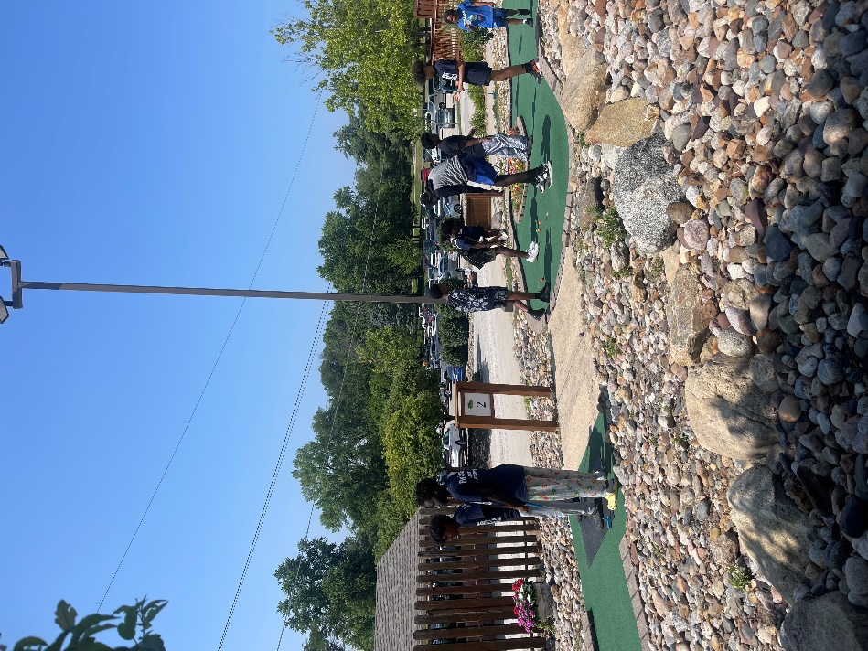
Figure 1 Students Engaged in Mini Golf Activity
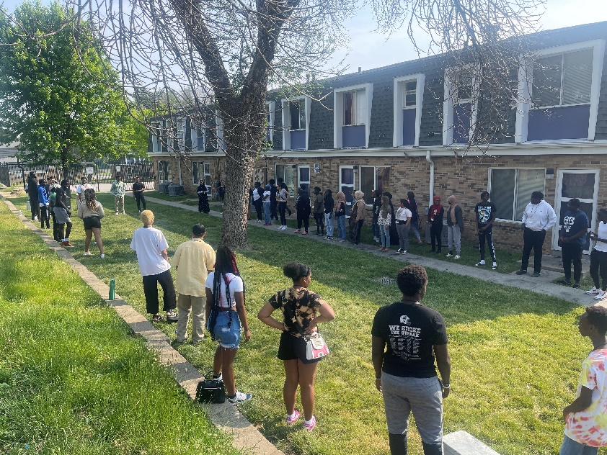
Figure 2 The Summer Youth Employment Program hosted an orientation for the students. Team building, learning and enrichment sessions are provided during the 3-4 day period to provide guidance and insight for the youth to help them better succeed in the workplace and in life.
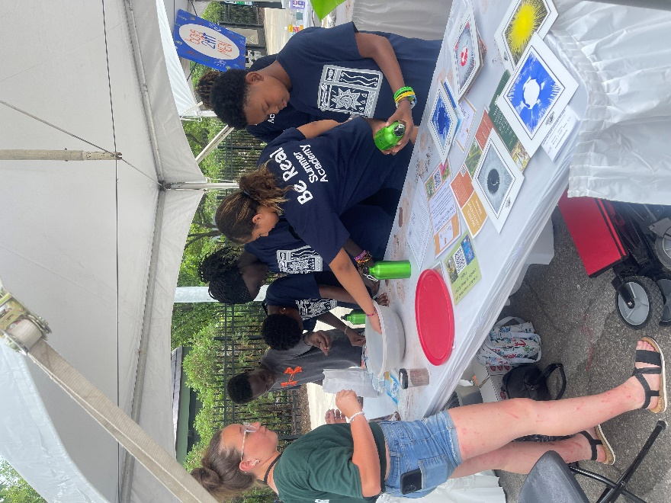
Figure 3 The youth love to attend the Art Festival every summer which immerses them in different art mediums that they might not have been introduced to. The youth love the street with all of the different tents with activities and art projects that are completel
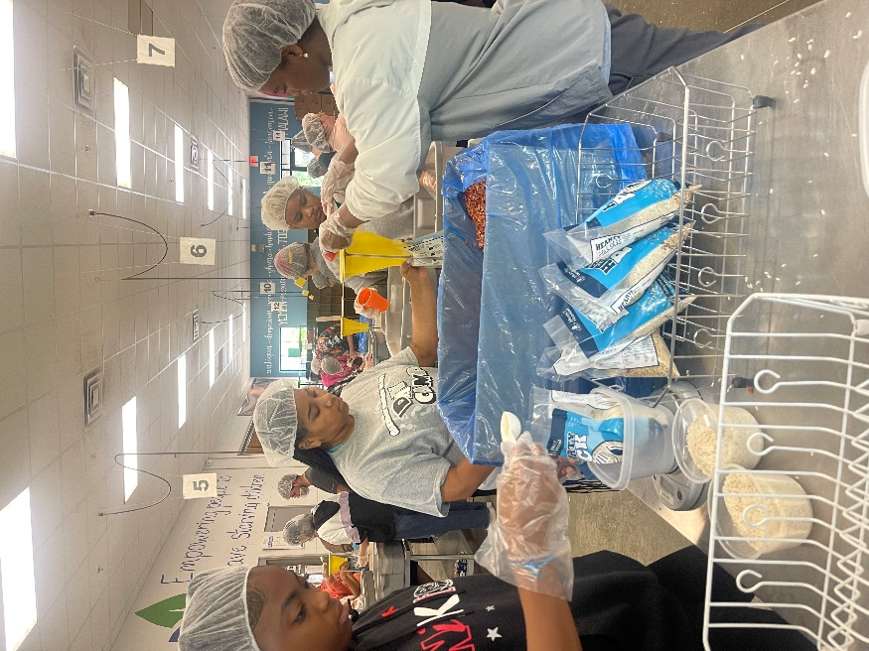
Figure 4 During the program the youth are involved in different Friday activities called “Fundamental Fridays”. This particular Friday some of the youth volunteered at Meals of The Heartland and packed close to a record breaking box total.
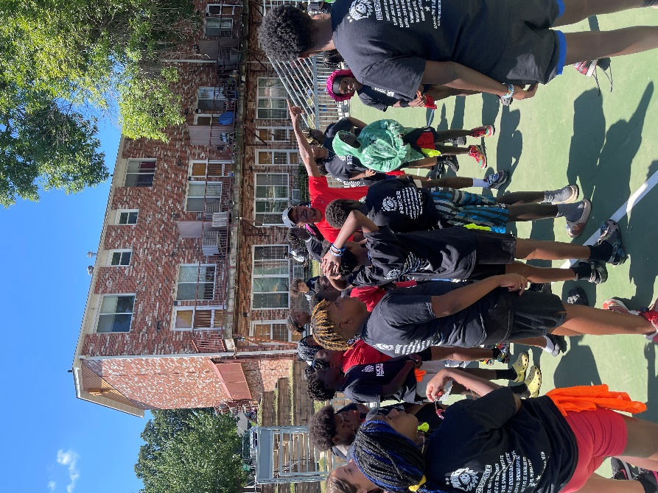
Figure 5 The Iowa Menace (local professional soccer team) came to campus to host a soccer clinic for the kids in the summer program. The kids learned different skills and even played some scrimmage games against each other.
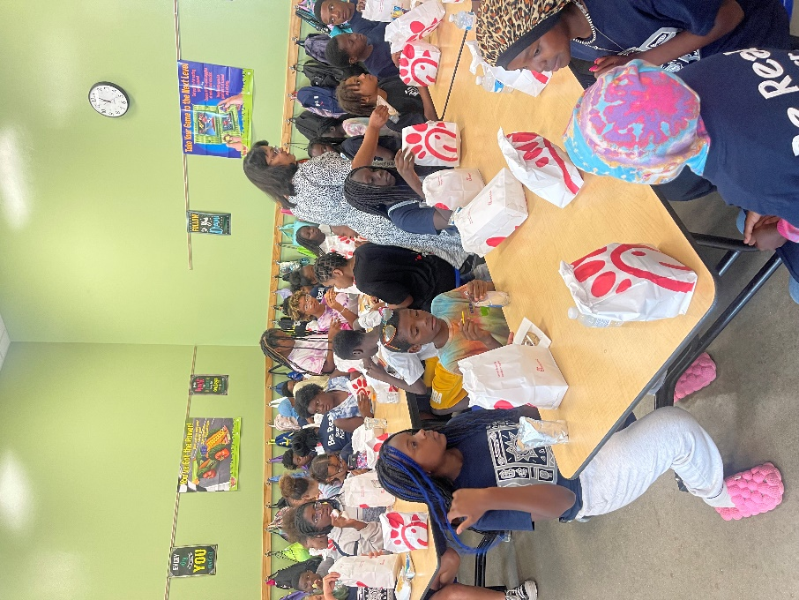
Figure 6 Representatives from Iowa Realty came and brought the kids and staff Chick-fil-a for an amazing lunch. The kids enjoyed talking with the realtors and sharing their stories.
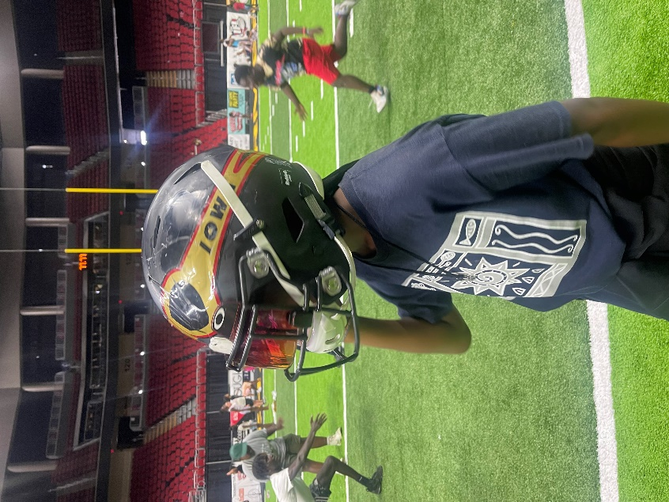
Figure 7 The Be Real program participated in a meet and practice with the Iowa Barnstormers football team. The kids had an absolute ball and even got signatures to take home with them.
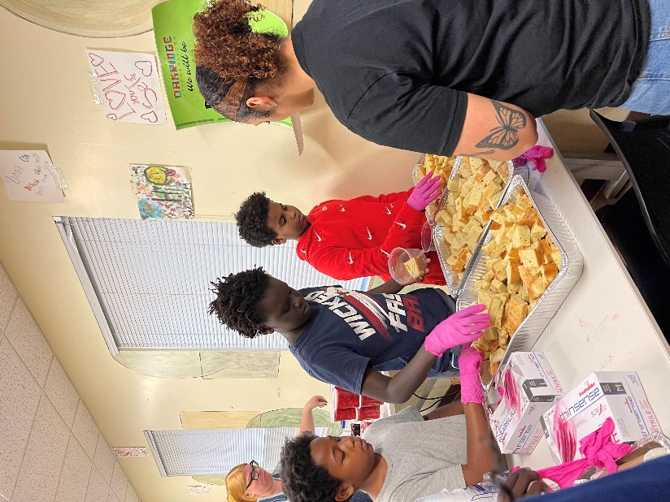
Figure 8 During the school year the Central Campus culinary program came to cook a few things with the students. On this particular day the youth made strawberry short cake that was amazing!
Student, teacher, parent, and stakeholder input
Student, teacher, parent, and stakeholder input Required Elements | Complete?
Quotes from student, teacher, parent, partners, and stakeholders. | X
Quotes should be attributed (titles can be used but names only with permission). | X
Showcase success of the program, especially for student attendance, behavior and academic success. | X

Quotes from Students:
“It’s fun and helps people in school and they have other programs you could join.”
Quotes from Teachers:
“Students who attend Oasis after-school program are provided with a safe, supervised and welcoming environment. During their time at Oasis, students are given additional academic support in a smaller group setting, as well as the opportunity for them to explore other interests. Students who consistently attend improve their math and reading scores, as well as gain self-confidence in so many ways. Kids can work on relationship building skills, cooperative play, improve their critical thinking and collaborate with peers to solve problems. The opportunities Oasis provides focus on the whole child and empowering them to become the best version of themselves!” Janice Miller, teacher at Edmunds Elementary and the Oakridge Neighborhood 21st CCLC after school program.
“(5th Grade Student) has received a multitude of valuable opportunities through the program. She is shining!” 5th Grade Teacher.
“5th Grade Student) has improved in all aspects of school – academically and behaviorally, as well as socially.” 5th Grade Teacher.
Quotes from Parents:
“The staff is always helpful and tells me when there is a problem. My child is learning to think before acting and is improving in reading.”
Quotes from Partners:
“The Central Iowa Professionals Chapter of National Society of Black Engineers has forged a dynamic partnership with the Oakridge Neighborhood in Des Moines, where K-12 students are members of a local NSBE Jr. chapter. Professional members serve as mentors, guiding students in essential STEM skills while fostering a culture of critical thinking and innovation. Throughout the school year, the chapter organizes engaging, hands-on learning activities and bi-weekly STEM workshops to inspire students and equip them with proficiencies vital for future career success. Recently, they established a FIRST Lego League robotics team, providing an additional avenue for students to develop leadership skills and embody core values of discovery, innovation, impact, inclusion, teamwork, and fun.” Central Iowa Professionals Chapter of National Society of Black Engineers.
“The Links, Incorporated has been the driving force behind a dynamic three-way partnership with Oakridge and National Society of Black Engineers (NSBE), fostering the weekly STEM programs NSBE Jr. and 926 Robotics. The Links’ steadfast commitment to community building and service to the African Diaspora has been the cornerstone of this collaboration’s success. Over the years NSBE Jr. and 926 Robotics have evolved into shining examples of how professionals can influence impressionable young students through their unwavering dedication. These programs strike the perfect balance between teaching theoretical STEM concepts and applying them through practical, hands-on activities. This unique approach ensures that students not only grasp these concepts but also retain them through experiential learning. The Links Inc are proud of this collaboration, knowing that it is paving the way for the next generation of scientists and engineers. Together, we are creating a legacy of excellence and innovation in STEM education for the youth of Oakridge Neighborhood.” Links Inc. Des Moines Chapter
Quote From A Teacher:
“I’ve founds what I love, and I want to continue to “up the scale” and increase my influence on more kids. I love this community and love working with these kids, and I also see myself expanding my reach – for as long as I can – and would like to keep raising the scale.” Mr. E.
- Showcase success of the program, especially for student attendance, behavior and academic success.
A theme that runs throughout the stakeholder input is the strong communication between and among the Oakridge 21st CCLC program, students, parents and the schools. The program has emphasized the importance of communication from school to home and home to school.
The program staff conducted small groups with students to discuss what was working well at school and what was not working well and did some problem solving on how to navigate the school day. The focus is on specifying what is needed to address short term goals. Staff have identified the students who most frequently disrupt the classroom and work with them to keep them from going to the school office and getting an office referral while at the same time help them to calm down using social emotional best practices. The program staff is consistently in the school buildings every day and often help the classroom teacher by pulling students into the hallway and getting them re-directed when they are engaging in disruptive behaviors. School staff and administrators are quick to point out how helpful this presence is in the building.
Staff help students pull their grades up by working with the school to find out if students have any missing assignments and helping the student complete those assignments. The certified teachers in the after-school program staff help with tutoring the students and these efforts have resulted in better GPAs. Because the Oakridge staff go over to Edmunds and walk students from Edmunds to Oakridge, the students see the staff talking to teachers to feed information back to the staff. The after-school staff do not report the kind of behavior issues students display during the school day. The staff identifies those with LEP or special needs that may need additional support. Staff get involved with the “high energy” students by meeting them at their level to ensure success. During staff meetings, students who have complications at school and in the community are discussed along with strategies on how to best meet their needs.
******************************************************************************
2023-2024 Oakridge Student Interviews
Eighteen students enrolled in the Oakridge Neighborhood 21st CCLC were interviewed individually or in focus groups as part of the 2023-2024 evaluation. Ten students enrolled in OASIS ranging in grades from 2nd to 5th participated in a focus group and their responses are summarized to maintain confidentiality. Eight students enrolled in BE REAL were interviewed in a focus group ranging in grades from 7th to 10th. All responses from the OASIS and BE REAL students are summarized together to maintain confidentiality. All students were asked the same questions and the following is a summary of their responses.
OASIS:
- What grade are you in?
2nd – 5th

- What do you like about the OASIS Program?
- I like that the people who work here are nice.
- Sometimes we play pool in the game room. We do lots of things that are fun.
- I like that we do fun stuff like learning, and the teachers.
- It is fun. You get to play games and we get to have free time, we get snacks at the beginning.
- I like to do exercises, our teacher does discipline and gets us ready for the world. We play a game called suicide on the basketball court, you go running from the free throw line.
- I get to play with my friends.
- I like that it is super fun and we do a lot of activities like dodge ball, kick ball, four square, game room with a Wi, we did a play, teachers they do learning which is really fun.
- You can have fun, chill out and talk to people, see your friends, play what you want and have a good time.

- What are some of your favorite things to do in the Program?
- Play soccer, play pool.
- Play basketball.
- Math, field trips, science, roller skating.
- Play basketball, play bumper pool, we need another one because it’s falling apart, play four square and basketball.
- Seeing and playing with my friends and playing basketball.
- Play soccer, play bumper pool.
- Four square, dodge ball, hanging out with friends.
- Play basketball, talk to my friend, four square, hang out with some of the girls who are my friends.

- Has the OASIS Program helped you to do better in school? If so how?
- Yes, to do better math, and they helped my learning like with reading.
- Yes, how to listen and how to do good handwriting.
- Kind of, I always do the same in school.
- Yes, with my manners and with my education. To learn manners we have to stand in line and look at the person you are talking to, if we don’t we get a consequence, we are disciplined. I like it because its affordable for kids that don’t have a lot of money.
- Yes, cause in 3rd grade I was moved up in the summer because I was doing well, my favorite subject is math.
- Yes, by learning things.
- Yes, it actually helps. Like in 4th grade we had this teacher we would do math stuff like double digits times double digits.
- Yes, it helps me when we do reading, math, one time we did math that helped me.

- Do you feel safe at the Program? If yes, how does the staff help you to feel safe? If no, what can the staff do to help you feel safe?
- Yes, by making me feel happy, by helping me learn and just like being there for me.
- Yes, probably by like helping us to make sure we don’t get lost, they keep an eye on us.
- Yes, very much. Just feel safe because we are there in the building, because they are kind.
- Yes, it provides really good safety. They are looking out for us the whole time, like in summer there is always someone in the pool with us.
- Yes.
- Yes, I think the teachers are always paying attention to make sure students are ok. If someone gets hurt they help, it’s a good community.
- Yes, I have people that have my back, if someone is going to hurt me I can tell the teacher and they will help me.

- Does the Program help you to make good decisions?
- Yes, because if we do bad decisions then we get in trouble.
- Yes, by being a good leader, by showing how to be an example by your teachers.
- I do my own thing.
- Yes, they help us to do a good job of helping us with manners.
- Yes, I know that with bad decisions comes with a punishment, so I try to make the right decisions the first time.
- Yes, to help others.
- Yes, they teach us like not doing drugs, it’s not right to kill people. The program helps us make good decisions.
- Yes, one time I was in 4th grade I was a trouble maker. My teacher told me that we do not have disrespectful people in the program and that helped me change my ways.

- Does the program help you to cope with challenges you face? If so, how?
- Yes, like when I don’t understand words or math problems.
- Not really.
- Yes, it helps me overcome challenges.
- Yes, I don’t have a lot of challenge, I see other people having challenges that they have helped.
- No.
- Not really.
- Yes, lets say that if my parent were getting a divorce, they are not, but if they see me acting weird they would help me.

- What could be improved about the program?
- I don’t know, it’s already great.
- Sometimes you do your job and you might get a consequence if you don’t do what you’re supposed to do the first time. 2nd graders can be an example for the kindergarteners.
- More staff.
- Need a new bumper pool table, more activities, they took away a lot of activities. Have another room for games in the Variety center and we should be able to go to the Teen Center. Travel more during the school year, go to sports events, we can go out of town to Minnesota to see Timberwolves. It would fun and it would an adventure, you could bring in 10 or 5 dollars from the parents, 3rd – 5th graders and Teen Center students.
- Honestly no not really, I like it just the way it is, he disciplines us and we have fun.
- Can’t think of anything.
- Add more people add more snacks and more upgraded snacks, anything like chips. On Fridays we get to pick, like to add Ritz crackers, smoothies with fruit or dessert, make our own milkshakes.
BE REAL:
- What grade are you in?
7th – 10th

- What do you like about the BE REAL Program?
- Good opportunity for academic tutoring if you need help.
- Gives us a place to go when we’re bored. The staff is nice and we have fun.
- It’s fun learning new things here, I learned about the history of Center Street.
- The staff helps us to talk about emotions.
- The staff is very welcoming.
- We can experience many opportunities.

- What are some of your favorite things to do in the Program?
- Talk to the staff.
- Have fun and make new friends.
- Talk to my friends and staff.
- Improving academic things and grades.
- Projects like STEAM, art, MLKing Day mural, painting with oil and pastels.
- Robotics on Saturdays. We build robots and presented to the younger students.

- Has the BE REAL Program helped you to do better in school?
- Yes, I have teachers that help me figure out my subjects.
- They make sure we contact our teachers.
- The staff texts the teacher to find out how I can pull up my grades.
- We have grade checks, they pull up my information on Infinite Campus and check the grades and see if we have any missing assignments.
- Program for high school students, we are remodeling a bike, then we can showcase and sell the bike.
- It helps me do better, pay attention more in class.

- Do you feel safe at the Program? If yes, how does the staff help you to feel safe?
- They sit down and talk to you.
- There is always at least one staff in each room to make sure everything is ok.
- The staff are trustworthy and help us with issues.

- Does the Program help you to make good decisions?
- Yes, they tell you what is right from wrong.
- If you think about making bad decisions, they help you realize consequences.

- Does the program help you to cope with challenges you face? If so, how?
- Yes, they tell me to keep doing something
- When people get frustrated or mad they make sure they calm down before they do something they would regret later.

- What could be improved about the program?
- Nothing, it’s perfect as it is (all agreed).
*************************************************************************************
A written survey was conducted with K-12 students in the program and completed by forty-three students. The following chart contains the results:
Results of 2023-2024 Student Survey
Question | Response
Has the OASIS/BE REAL program helped you in school? | 30: Yes  13: No
Who is your favorite person at school? | 25: Classmate  13: Teacher  4: Counselor  5 : Other
What is your favorite subject at school? | 4: History  7: Math  3: Language Arts
What do you like about the OASIS/BE REAL Program? | 18: Snacks  14: Field Trips  13: Other; game room, art and staff  18: Classes
Do you feel safe at the OASIS/BE REAL program? | 36: Yes  0: No  8: Sometimes
What grade are you in? | 21: Elementary  22: Secondary

Survey results with students showed that 70% of students agreed that the program helped them in school and 100% reported feeling safe at the OASIS and BE REAL program.
Student comments on the survey:
- “I can go here after school when I don’t have anything to do after school’s over. I get opportunities here.”
- “It’s fun and helps people in school and they have other programs you can join.”
- “I do things that sometimes I did not do before. My favorite classes are Science and Math.”
- “Staff helping with school work and always talking about things I wanna work on.”
- “Being able to connect with different people and learning new things.”
******************************************************************************
YOUTH PROGRAM QUALITY ASSESSMENT REPORT, Oakridge Neighborhood Services, Des Moines, Iowa, 2024
This report summarizes the program quality assessment of Oakridge Neighborhood Services After-School Program. The assessment was completed as part of the United Way Quality Counts project to gather and analyze data on the quality of youth programs across a variety of settings and funding streams. The data on your program will be compiled with similar assessments of approximately fifty youth programs to produce a snapshot of youth program quality in Iowa.
The instrument used to complete the appraisal was the Youth Program Quality Assessment (PQA), a research-validated observation tool developed by High/Scope Educational Research Foundation. Data collection included on-site observation and staff meeting.
The YPQA measures quality on four programmatic subscales and on three organization-level subscales. The following table summarizes your program offering scores, compared to national norms based on High/Scope's assessment of more than 500 youth program offerings across the country. Scores range from 1.0 to 5.0, where 5.0 is the best possible score.
 | Oakridge Neighborhood | National Norms

I. Safe Environment | 4.50 | 4.35
II. Supportive Environment | 5.00 | 3.70
III. Peer Interaction | 5.00 | 2.95
IV. Youth Engagement | 5.00 | 2.57
Attached is a detailed score report for your program. While the scores are based on a brief observation of your program, we believe it provides useful information about key aspects of youth program quality that can help guide program design and staff development efforts. We encourage you to use these results to stimulate conversation within your organization about program quality and to inform quality improvement efforts.
Strong items of note in your assessment include:
(III-N1) All youth have multiple opportunities to practice group-process skills (e.g., actively listen,
contribute ideas or actions to the group, do a task with others, take responsibility for a part). 5.00
(II-H2) The program activities lead (or will lead in future sessions) to tangible products or
performances that reflect ideas or designs of youth. 5.00
(II-G3) There are enough materials and supplies prepared for all youth to begin activities. 5.00
E. Healthy food and drinks are provided. 5.00
Items that may warrant attention include: (list lowest four items)
P. Youth have opportunities to set goals and make plans. 4.00
M. Youth have opportunities to participate in small groups. 5.00
K. Staff use youth-centered approaches to reframe conflict. 4.00
Q. Youth have opportunities to make choices based on their interests. 5.00
Also attached is information developed by High/Scope about interpreting PQA data. More information about High/Scope, the assessment instrument, and the validation study, can be found on the High/Scope website at www.highscope.org.
Scores Report
High/Scope Youth Program Quality Assessment

Summary Report
Organization: Oakridge Neighborhood Services
Form A
I. Safe Environment 5.00
A. Psychological and emotional safety is promoted. 5.00
B. The physical environment is safe and free of health hazards. 5.00
C. Appropriate emergency procedures and supplies are present. 5.00
D. Program space and furniture accommodate the activities offered. 5.00
E. Healthy food and drinks are provided. 5.00

II. Supportive Environment 5.00
F. Staff provide a welcoming atmosphere. 5.00
G. Session flow is planned, presented, and paced for youth. 5.00
H. Activities support active engagement. 5.00
I. Staff support youth in building new skills. 5.00
J. Staff support youth with encouragement. 5.00
K. Staff use youth-centered approaches to reframe conflict. 5.00

III. Interaction 4.50
L. Youth have opportunities to develop a sense of belonging. 4.00
M. Youth have opportunities to participate in small groups. 5.00
N. Youth have opportunities to act as group facilitators and mentors. 4.00
O. Youth have opportunities to partner with adults. 5.00

IV. Engagement 4.67
P. Youth have opportunities to set goals and make plans. 4.50
Q. Youth have opportunities to make choices based on their interests. 5.00
R. Youth have opportunities to reflect. 4.50

Detailed Report
Organization: Oakridge Neighborhood Services
I. Safe Environment | 4.95
A. Psychological and emotional safety is promoted. | 5.00
(1-A1) The emotional climate of the session is predominately positive (e.g., mutually respectful, relaxed, supportive; characterized by teamwork, camaraderie, inclusiveness, and an absence of negative behaviors). Any playful negative behaviors (not considered offensive by parties involved) are mediated (countered, curtailed, defused) by staff or youth. | 5.00
(I-A2) There is no evidence of bias but rather there is mutual respect for and inclusion of others of a different religion, ethnicity, class, gender, ability, appearances, or sexual orientation. | 5.00
B. The physical environment is safe and free of health hazards. | 4.75
(I-B1) The program space is free of health and safety hazards. | 4.50
(I-B2) The program space is clean and sanitary. | 4.50
(I-B3) Ventilation and lighting are adequate in the program space. | 5.00
(I-B4) The temperature is comfortable for all activities in the program space. | 5.00
C. Appropriate emergency procedures and supplies are present. | 5.00
(I-C1) Written emergency procedures are posted in plain view. | 5.00
(I-C2) At least one charged fire extinguisher is accessible and visible from the program space. | 5.00
(I-C3) At least one complete first-aid kit is accessible and visible from the program space. | 5.00
(I-C4) Other appropriate safety and emergency equipment (e.g., for water or vehicle safety, sports, or repairs) is available to the program offering as needed, can be located by staff, and is maintained in full-service condition. | 5.00
(I-C5) All entrances to the indoor program space are supervised for security during program hours (can include electronic security system). | 5.00
(I-C6) Access to outdoor program space is supervised during program hours. | 5.00
D. Program space and furniture accommodate the activities offered. | 5.00
(I-D1) Program space allows youth and adults to move freely while carrying out activities (e.g., room accommodates all participants without youth blocking doorways, bumping into one another, and crowding). | 5.00
(I-D2) Program space is suitable for all activities offered (e.g., furniture and room support small and large groups; if athletic activity is offered, then program space supports this). | 5.00
(I-D3) Furniture is comfortable and of sufficient quantity for all youth participating in the program offering. | 5.00
(I-D4) Physical environment can be modified to meet the needs of the program offering (e.g., furniture and/or supplies can be moved). | 5.00
E. Healthy food and drinks are provided. | 5.00
(I-E1) Drinking water is available and easily accessible to all youth. | 5.00
(I-E2) Food and drinks are plentiful and available at appropriate times for all youth during the session. | 5.00
(I-E3) Available food and drink is healthy (e.g., there are vegetables, fresh fruit, real juice, or homemade dishes). | 5.00

II. Supportive Environment | 4.96
F. Staff provide a welcoming atmosphere. | 5.00
(II-F1) All youth are greeted by staff within the first 15 minutes of the session. | 5.00
(II-F2) During activities, staff mainly use a warm tone of voice and respectful language. | 5.00
(II-F3) During activities, staff generally smile, use friendly gestures, and make eye contact. | 5.00
G. Session flow is planned, presented, and paced for youth. | 5.00
(II-G1) Staff start and end session within 10 minutes of scheduled time. | 5.00
(II-G2) Staff have all materials and supplies ready to begin all activities (e.g., materials are gathered, set up). | 5.00
(II-G3) There are enough materials and supplies prepared for all youth to begin activities. | 5.00
(II-G4) Staff explain all activities clearly (e.g., youth appear to understand directions; sequence of events and purpose are clear). (some students do have a LD which directions may need to be repeated) | 5.00
(II-G5) There is an appropriate amount of time for all the activities (e.g., youth do not appear rushed, frustrated, bored, or distracted; most youth finish activities). | 5.00
H. Activities support active engagement. | 5.00
(II-H1) The bulk of the activities involve youth in engaging with (creating, combining, reforming) materials or ideas or improving a skill through guided practice. | 5.00
(II-H2) The program activities lead (or will lead in future sessions) to tangible products or performances that reflect ideas or designs of youth. | 5.00
(II-H3) The activities provide all youth one or more opportunities to talk about (or otherwise communicate) what they are doing and what they are thinking about to others. | 5.00
(II-H4) The activities balance concrete experiences involving materials, people, and projects (e.g., field trips, experiments, interviews, creative writing) with abstract concepts (e.g., lectures, diagrams, formulas). | 5.00
I. Staff support youth in building new skills. | 5.00
(II-I1) All youth are encouraged to try out new skills or attempt higher levels of performance. | 5.00
(II-I2) All youth who try out new skills receive support from staff despite imperfect results, errors, or failure; staff allow youth to learn from and correct their own mistakes and encourage youth to keep trying to improve their skills. | 5.00
J. Staff support youth with encouragement. | 4.66
(II-J1) During activities, staff are almost always actively involved with youth (e.g., they provide directions, answer questions, work as partners or team members, check in with individuals or small groups). | 5.00
(II-J2) Staff support at least some contributions or accomplishments of youth by acknowledging what they've said or done with specific, non-evaluative language (e.g., “Yes, the cleanup project suggested is a way to give back to the community.” “I can tell from the audience response that you put a lot of thought into the flow of your video.”). | 5.00
(II-J3) Staff make frequent use of open-ended questions (e.g., staff ask open-ended questions throughout the activity and questions are related to the context). | 5.00
K. Staff use youth-centered approaches to reframe conflict. | 5.00
(II-K1) Staff predominately approach conflicts and negative behavior in a nonthreatening manner (i.e., approach calmly, stop any hurtful actions, and acknowledge youth's feelings). | 4.00
(II-K2) Staff seek input from youth to determine both the cause and solution of conflicts and negative behavior (e.g., youth generate possible solutions and choose one). | 5.00
(II-K3) To help youth understand and resolve conflicts and negative behavior, staff encourage youth to examine the relationship between their actions and consequences. | 5.00
(II-K4) Staff acknowledge conflicts and negative behavior and follow up with those involved afterward. | 5.00

III. Interaction | 5.00
L. Youth have opportunities to develop a sense of belonging. | 5.00
(III-L1) Youth have structured opportunities to get to know each other (e.g., there are team-building activities, introductions, personal updates, welcomes of new group members, icebreakers, and a variety of groupings for activities). | 5.00
(III-L2) Youth exhibit predominately inclusive relationships with all in the program offering, including newcomers. | 5.00
(III-L3) Youth strongly identify with the program offering (e.g., hold one another to established guidelines, use ownership language, such as “our program,” engage in shared traditions such as shared jokes, songs gestures). | 5.00
(III-L4) The activities include structured opportunities, (e.g., group presentations, sharing times, recognition celebrations, exhibitions, performances) to publicly acknowledge the achievements, work, or contributions of at least some youth. | 5.00
M. Youth have opportunities to participate in small groups. | 5.00
(III-M1) Session consists of activities carried out in at least 3 groupings – full, small, or individual. | 5.00
(III-M2) Staff use 2 or more ways to form small groups (e.g., lining up by category and counting off, grouping by similarities, signing up). | 5.00
(III-M3) Each small group has a purpose (i.e., goals or tasks to accomplish), and all group members cooperate in accomplishing it. | 5.00
N. Youth have opportunities to act as group facilitators and mentors. | 5.00
(III-N1) All youth have multiple opportunities to practice group-process skills (e.g., actively listen, contribute ideas or actions to the group, do a task with others, take responsibility for a part). | 5.00
(III-N2) During activities, all youth have one or more opportunities to mentor an individual (e.g., teach or coach another). | 5.00
(III-N3) During activities, all youth have one or more opportunities to lead a group (e.g., teach others; lead a discussion, song, project, event, outing, or other activity). | 5.00
O. Youth have opportunities to partner with adults. | 5.00
(III-O1) Staff share control of most activities with youth, providing guidance and facilitation while retaining overall responsibility (e.g., staff use youth leaders, semiautonomous small groups, or individually guided activities). | 5.00
(III-O2) Staff always provide an explanation for expectations, guidelines, or directions given to youth. | 5.00

IV. Interaction | 4.50
P. Youth have opportunities to set goals and make plans. | 4.50
(IV-P1) Youth have multiple opportunities to make plans for projects and activities (individual or group). | 4.00
(IV-P2) In the course of planning the projects or activities, 2 or more planning strategies are used (e.g., brainstorming, idea webbing, backwards planning). | 5.00
Q. Youth have opportunities to make choices based on their interests. | 5.00
(IV-Q1) All youth can make at least one open-ended content choice within the content framework of the activities (e.g., youth decide topics within a given subject area, subtopics, or aspects of a given topic). | 5.00
(IV-Q2) All youth can make at least one open-ended process choice (e.g., youth decide roles, order of activities, tools or materials, or how to present results). | 5.00
R. Youth have opportunities to reflect. | 5.00
(IV-R1) All youth are engaged in an intentional process of reflecting on what they are doing or have done (e.g., writing in journals; reviewing minutes; sharing progress, accomplishments, or feelings about the experience). | 5.00
(IV-R2) All youth are given the opportunity to reflect on their activities in 2 or more ways (e.g., writing, role playing, using media or technology, drawing). | 5.00
(IV-R3) In the course of the program offering, all youth have structured opportunities to make presentations to the whole group. | 5.00
(IV-R4) Staff initiate structured opportunities for youth to give feedback on the activities (e.g., staff ask feedback questions, provide session evaluations). | 5.00
Our scores went up in the areas of the This is a contribution of the intense Professional Development in, “Social Emotional Development Learning”, activities, we had speakers, we viewed the institute of Collaborative for Academic of Social Emotional Learning Program (CASE webinars, and open group discussion regarding setting goals, discussing cultures, and empathy.
The following areas of improvement are noted:
- B-The physical environments are safe and free of health hazards 4.50 5.00
- C-Appropriate emergency procedures and supplies are present 4.75 5.00
- G-Session’s flow is planned, presented, and paced for youth 4.80 5.00
- K-Staff use youth-centered approaches to refrain conflict 4.50 5.00
- L-Interactions 4.75 5.00
- M-Youth can participate in small groups 4.98 5.00
- N-Youth have opportunities to act as a facilitators and mentors 4.98 5.00

- Sustainability Plans
Sustainability Plans Required Elements | Complete?
Discuss formal sustainability plan from your original grant application including how it has changed. | X
How program will continue without 21st CCLC grant funding. | X
How partnership contributions will help the program continue (refer to partnership table from section 3). | X

Discuss the level of sustainability over the life of the grant. Explain how partner contributions can help sustain the program after federal funding ends.
- Discuss formal sustainability plan from your original grant application including how it has changed.
The original plan contained the following components:
- The long-term sustainability strategy will involve garnering broad-based community support, utilizing stakeholders to raise visibility of the program’s successes, and building new partnerships.
- The Oakridge Youth Director and other department staff are actively engaged with the Iowa After-School Alliance, the Campaign for Grade Level Reading and the United Way AS-OOS efforts.
- The program will continue to engage DMPS administrators, 21st CCLC staff and building principals. Those connections will continue to raise visibility regarding the Oakridge 21st CCLC program and provide an avenue for further engagement, conversations about shared services, and opportunities for program collaboration, all necessary in supporting the notion of sustainability.
- Oakridge will build the capacity of the program through one-time purchases of technology, equipment, and materials whose life span will extend well beyond the life of grant funds thus seeding the program and serving as a base for program sustainability.
- Additional in-kind and non-financial resources will be considered to help sustain elements of the program, such as in-kind collaborations with community organizations that share mutual goals with youth.

The program is managed by the 21st CCLC Project Manager. The Project Manager and an Education Coordinator currently retained by the organization interface with school building administrators, teachers and other building level staff to ensure all activities are aligned with school day instruction and focused on the individual and collective needs of the students being served. Each of the three sites has a site coordinator responsible for day-to-day programming and all sites are supported by the Director of Youth Programs. All staff are trained in YPQA methods and additional professional development (PD) is provided with a focus on cultural competency, best practice in AS-OOS programming, and other emerging and program specific topics. Des Moines Public Schools has agreed to allow 21st CCLC staff access to district PD appropriate to the positions funded by 21st CCLC. Long term program sustainability will be addressed through increased program visibility and the identification of partners and collaborators that add value and increase program effectiveness, results and impact.

- How program will continue without 21st CCLC grant funding.

Without 21st CCLC funding, the program would not be able to continue to employ teachers in the after-school program. The staff would work to recruit and expand the volunteer base and use lesson plans to identify student needs.

- How partnership contributions will help the program continue (refer to partnership table from section 3).

The Oakridge 21st CCLC maintained, added and eliminated partnerships in 2023-2024 for a total of 57 partnerships and a total in-kind value of $647,095. This is an increase in partnerships from 2022-2023 when there were 56 partnerships. Also attached to the evaluation is the “Oakridge Neighborhood Iowa Partners List 2023-2024” with additional information about each partner and what they provide. Partners provide critical support to K – 12 students in the areas of academic, enrichment and social emotional support. Partners are important in providing support and services at little to no cost to the program. Partners such as National Society of Black Engineers, Ballet Des Moines and Pro Iowa Soccer are all key partners and provide enrichment activities to enhance what the program staff provide.

- Summary and Recommendations
Summary and Recommendations Required Elements | Complete?
Summary of program. | X
Dissemination of local evaluation. | X
Recommendations for local objectives. | X
Recommendations on future plans for change. | X
Unexpected Data | X

Summary of Program
Summary of Program Required Elements | Complete?
Reference introduction section. | X
Showcase successes of program. | X
Highlight items contributing to program success. | X
Include exemplary contributions from staff, teachers, volunteers and/or partners. | X

- Reference introduction section
The main purpose of small group instruction for BE REAL is to work on special school projects and build success in math, reading, social studies, science and social emotional learning. Students completed computer work assigned by the school. They worked on a rotation of 30-minute intervals or more if needed. Tutoring sessions were led by teachers and peers. Certified teachers worked with groups of five to eight students and assisted students with special school projects. College students and volunteers worked one-on-one with students in the areas of math, reading, social studies and science. Students were encouraged to participate and work with staff on planning enrichment activities for after-school programming.
OASIS is the educationally based after-school program for students grades K-5 which focuses on increased math and reading proficiency, increased school attendance, decreased suspensions (in and out-of-school) and system involvement. This is accomplished through literacy/reading and math classes, individualized homework assistance, and school visits, plus one-to-one and group tutoring sessions. Students are provided instruction by certified teachers, as well as enrichment activities and other social and emotional supports by academic intervention specialists. Oakridge also connects grade schoolers’ STEM (science, technology, engineering, and math) education with STEAM, (science, technology, engineering, arts and math), adding arts curriculum and experiences. Students are given the opportunity to participate in a variety of fine arts programming through hands-on activities, workshops, field trips and artists-in-residence.
- Showcase successes of program.

- In interviews, students reported the program has helped them with comments such as “Yes, with my manners and with my education. To learn manners we have to stand in line and look at the person you are talking to, if we don’t we get a consequence, we are disciplined. I like it because its affordable for kids that don’t have a lot of money.” “Yes, I think the teachers are always paying attention to make sure students are ok. If someone gets hurt they help, it’s a good community.” “We have grade checks, they pull up my information on Infinite Campus and check the grades and see if we have any missing assignments.”
- Survey results with students showed that 70% of students agreed that the program helped them in school. One hundred percent reported feeling safe at the OASIS and BE REAL program. Survey results with parents showed 88% of parents reported being happy or very happy with the program and 92% of parents reported they find the staff to be courteous and friendly and the program site is a safe place for their child to be.
- Results from the Youth Program Quality Assessment include the program ranking higher than the national average on several indicators, including “all youth have multiple opportunities to practice group-process skills (e.g., actively listen,
contribute ideas or actions to the group, do a task with others, take responsibility for a part).”

- Highlight items contributing to program success.
The strength of the program comes from the relationship the program staff have with children most in need. The program rallies around identified portions of the community who need assistance. The program gives one-to-one support along with the school and helps the school find students who need support.
- Include exemplary contributions from staff, teachers, volunteers and/or partners.
Exemplary contributions from staff include the amount of time and effort the program staff invest into the program, often volunteering their time in addition to their regular responsibilities and donating their own money for activities. The staff helps families obtain food, transportation, and support. Teachers provide much needed academic, behavioral and social emotional learning opportunities and individualize instruction to meet the needs of every student. They take a “whole child” approach by recognizing the range of aspects each child brings to the learning environment. Volunteer groups provide much needed support to fill gaps beyond paid staff. Partnerships add enrichment and fun opportunities for the students and they go above and beyond expectations, including providing materials, transportation, and extra time.
Dissemination of Local Evaluation.
Dissemination of Local Evaluation Required Elements | Complete?
Exact URL where your 2023-2024 local evaluation is posted (required by US DOE). Because this is required by ESSA, we check each URL for accuracy. | X
Discussion of other methods of Dissemination (Board reports, community meetings, person to person, e-mail, etc.) | X

Paste exact URL where your 2023-2024 local evaluation is/will be posted (required by US DOE). The URL should pull up the Local Evaluation, not just the page where it can be found. The URL should also not download the file. The Local Evaluation should be readable in the browser window.
If the Local Evaluation will be posted once it is finalized, please indicate that here.
- Exact URL where your 2023-2024 local evaluation is posted (required by US DOE).
The evaluation is posted here: https://oakridgeneighborhood.org/wp-content/uploads/2025/04/Oakridge-Neighborhood-Services-Local-Evaluation-Form-2023-2024.pdf
- Discussion of other methods of Dissemination (Board reports, community meetings, person to person, e-mail, etc.)
The evaluation will also be shared with the Board of Directors of the Oakridge Neighborhood Services Inc. A Twitter and a Facebook account also exist and will be used to direct individuals to the website. Twitter: @OakridgeServes. Facebook: https://www.facebook.com/pg/OakridgeNeighborhoodServices/
Recommendations for Local Objectives.
Recommendations for Local Objectives Required Elements | Complete?
Objectives to be changed and reasons why. | X
Objectives to be added. | X
Include objectives not met. | X
Include objectives not measured. | X

Remember to include an evaluator discussion on how the program met or did not meet the local objectives.
- Objectives to be changed and reasons why.

The program is changing the target percentages for Goal 2 and Goal 4.
Goal 2: Change the percentage from 80% to 65% of participants demonstrate success in reading and from 80% to 65% demonstrate success in math as measured by report card grades of C or better in those subjects.
Goal 4: Change the percentage from 80% to 65% of participants will maintain eighteen (18) or fewer absences per year as measured by Infinite Campus reports.

The reasons for these changes are to more realistically align the percentages with the reality of the challenges program participants face related to report card grades and absences. Due to the recent transition of families leaving the program and new families entering the program, this high mobility creates challenges.

- Objectives to be added.
None at this time.
- Include objectives not met.
Three of five local objectives were met.
- Include objectives not measured.
All objectives were measured.
Recommendations on Future Plans for Change.
Recommendations on Future Plans for Changing Required Elements | Complete?
Changes in activities. | X
Changes in recruitment efforts. | X
Changes in partnerships. | X
Changes for sustainability plans. | X
Other changes as suggested by governing body. | X

Remember to include an evaluator discussion of what can be done to improve the program
- Changes in activities

Changes in activities during the 2023-2024 school year include:

The program implemented an Art Club facilitated by program staff including hands on craft activities such as making pinatas from carboard boxes and crepe paper to take home and use, Kids in the Kitchen with HyVee where students learned how to cook simple meals, and the Robotics Club where students learned how to build their own robots with help of employees from John Deere.

An evaluator discussion of what can be done to improve the program includes continuing to find ways to improve communication with Des Moines Public Schools related to obtaining student data needed for the 21st CCLC evaluation. Oakridge Neighborhood staff obtain signed releases of information from the parents of the students participating in the program allowing the district to release the data to Oakridge Neighborhood, as a nonprofit agency outside of the district’s internal system. The delays in receiving the GPRA and Local Objectives data has caused the program to seek extensions for the past several years.

- Changes in recruitment efforts
There are no significant changes to the recruitment process. The Oakridge Neighborhood 21st CCLC continues to reach out to students and families door to door to let them know about the summer and after-school program, collaborates with the school buildings to refer students to the program, and provides information at orientation for new families moving in to the housing program.
- Changes in partnerships
Partnerships are ever changing; while some partners have longevity with the program, new ones are constantly added. The program also notes that it is forming deeper relationships with community partners and being more purposeful in identifying what is of most benefit to students in the program. This includes an emphasis on building on successes and enhancing activities that are responsive to participant’s needs.
- Changes for sustainability plans.
With the change in the rules for receiving the 21st CCLC grant for a ten-year period, the Oakridge Neighborhood After-school program applied and submitted a grant application for the next round. The program will continue to expand on the existing 57 partnerships to help meet the needs of students and families and will continue to seek grants, other funding and expanded partnerships. Program staff collaborate with United Way of Central Iowa to identify areas of unmet need and to seek funding and partnerships to meet those needs.
- Other changes as suggested by governing body.
The 21st CCLC will continue to work with United Way of Central Iowa to customize and accommodate the expansion of the “Compile” data base system to allow the program to collect more data electronically which will result in more efficiencies in the system related to reports.
- Based on the data, recommendations for improving program quality.
One recommendation for improving program quality is using more technology aids such as tablets and the computer lab to enhance student learning tools. Students are excited about using the tablets and the program looks forward to using technology more as those opportunities continue to increase. To increase reading and math scores the program can expand the use of web-based programs from Edmunds Elementary School. The use of the latest technology can enhance the academic component of enrichment activities such as robotics and drones conducted in partnership with NSBE Jr. and using more technology with younger students.
UNEXPECTED DATA (Unusual circumstances that occurred during the past school year- Flood, Tornado, Storm, Pandemic or other) Explain how this affected the program and how you responded to continue to serve children. What new procedures did you introduce? How did the Staff, Students and Parents respond? You may include pictures to help illustrate the challenges faced because of natural disaster(s).
There were no unusual circumstances that occurred during the past school year.

